**Cosmology and stellar evolution**

Contents

**Preliminary learning** 3

Astrophysical context 3

Additional assumptions 4

**Chapter 1 – Introduction** 5

**1.1 Astrometry** 5

**1.1.1 Few comments/statements:** 5

**1.1.2 Geographic coordinates** 6

**1.2 Distance, luminosity, flux** 10

**1.2.1 Angles:** 10

**1.2.2 Trigonometric parallax** 10

**1.2.3 Examples** 11

**1.2.4 Luminosity flux and intensity** 12

**1.2.5 Magnitude system** 13

**1.3** **Blackbody Radiation** 17

**1.3.1 Wien’s law** 19

**1.3.2 Stefan-Boltzmann law** 20

**Chapter 2 – Stars and their evolution** 20

**2.1 The Hertzsprung-Russell (HR) diagram** 20

**2.1.1 Spectral classification** 20

**2.1.2 Interpreting the HR diagram** 24

**2.1.3 Stellar radius** 25

**2.1.4 Spectroscopic parallax** 27

**2.1.5 Key characteristics** 28

**2.1.6 Mass-radius relation** 28

**2.1.7 Mass-Luminosity relation** 28

**2.1.8 Stellar age/lifetime** 29

**2.2 Physics principles: energy source and transport** 31

**2.2.1 Hydrostatic equilibrium** 31

**2.2.2 Source of energy: nuclear fusion** 34

**2.2.3 Transport of energy** 39

**2.2.4 Star’s modelling** 42

**2.3** **Star’s formation** 44

**2.3.1 Observational evidence** 44

**2.3.2 Stages of evolution** 47

**2.3.3 Jeans length and mass** 48

**2.3.4 Virial theorem** 48

**2.4** **Journey towards and away from the main sequence** 49

**2.4.1 Pre-main sequence evolution** 49

**2.4.2 Lifetime on the main sequence** 50

**2.4.3 Post-main sequence evolution** 50

**2.4.4 Pulsating variable stars** 60

**2.5** **Stellar remnants** 61

**2.5.1** **White dwarfs** 61

**2.5.2** **Supernovae** 64

**2.5.3** **Neutron stars/pulsars** 65

**2.5.4** **Black holes** 68

**Chapter 3 – Galaxies** 69

**3.1 The Milky Way** 69

**3.1.1 The disk** 70

**3.1.2 The halo** 70

**3.1.3 The Bulge** 71

**3.1.4 The mass of the Milky Way** 72

3.2 **The Hubble classification** 73

**3.2.1 Hubble’s law** 74

**3.3 Galaxy formation and mergers** 76

**3.4 Clusters and local environment** 80

**3.4.1 Different types of star clusters** 80

**Chapter 4 – Introduction to cosmology** 80

**4.1 The Expanding universe** 80

**4.1.1 Overview** 80

**4.1.2 The Olber’s paradox** 81

**4.1.3 The cosmological principle** 81

**4.1.4 Modelling the expansion** 83

**4.2 Models of Universe(s)** 97

**4.2.1 Empty universes** 97

**4.2.2 Friedmann models** 99

**4.3 The Early Universe** 102

**4.3.1 Important parameters** 102

**4.3.2 The Thermal History of the Universe** 104

**4.3.3 Physis of the Big Bang** 105

**4.4 Miscellaneous topics** 109

**4.4.1 The Horizon problem** 109

**4.4.2 The flatness problem** 111

**4.4.3 Gravitational lensing (including lens equation and lens potentials)** 114

**4.4 Gravitational waves (including wave equation in general relativity)** 117

**4.5 Black holes (including Schwarzschild metric, Hawking radiation, event horizon)** 117

# **Preliminary learning**

## Astrophysical context

Table

|  |  |  |
| --- | --- | --- |
| Object | Lookback time | Terrestrial context |
| Centre of milky way galaxy | 25000 years | Ice age(s) |
| Andromeda nebula | 2,000,000 years | Primitive man |
| Virgo | 40x106 years | Dinosaurs |
| Coma (cluster of galaxies) | 200x106 years |  |
| Nearest quasar | 109 years | Primitive multicellular life |
| Distant galaxies | 5x109years | Earth formed |
| Most distant quasar/galaxy | 15x10219 years | Universe only 10% of its present age |

## Additional assumptions

1. The laws of physics are universal, at all times and at all places. We can understand the universe on terms of the laws we define on Earth.
2. The converse is also true, we can use astronomical measurements/observations to test laws of physics.

**Example 1: Strong gravitational field**

The light from background stars are bent during a solar eclipse (strong gravitational lensing) as predicted by general relativity and stellar lensing and can be easily tested on Earth.

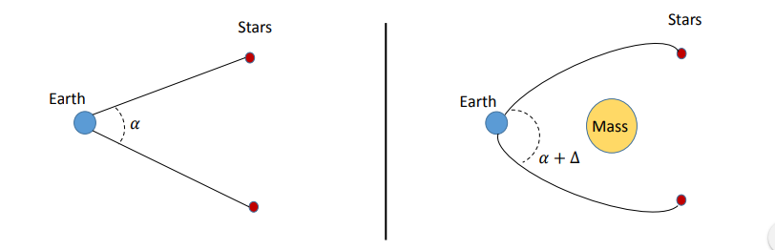

Figure

**Example 2: Vast range of densities**

Atomic physics at:

* Low density: interstellar medium of 1 proton per cubic centimetre (1H cm-3)
* High density: a pulsar, a star made completely of neutrons (1014 g cm-3)

**Example 3: Vast range of magnetic fields (or magnetic flux)**

An incredible range of magnetic fields exist, allowing to test physical laws in the extreme



Weak magnetic field: Interplanetary space

Strong magnetic field: Surface of neutron stars

**Example 4: Energy generation**

A quasar produces 1040 W in a volume approximately the size of our solar system

The Sun isonly 0.7% efficient

Mechanisms: nuclear reaction, convective motion, radiative transport, …

# **Chapter 1 – Introduction**

## **1.1 Astrometry**

### **1.1.1 Few comments/statements:**

* The Sun spins around its axis
* The Earth rotates around the Sun
* The plane including the Sun and the Earth is called the ecliptic plane
* The Earth spin axes is inclined at 23o27’ (degree and arcminute)
* From Earth, the Sun is moving in the sky in the Zodiac
* The Sun is moving along a branch of the spiral galaxy, the Milky Way
* The stars are at infinity
* The position of stars depends on the location of the observer and the time of the year
* The height of the Sun in the sky depends on the season
* Close stars seem to move relatively to each other
* Planets and stars follow Kepler’s laws

**Method to find coordinates in the universe**

* Define a reference axis
* Define a reference plane, perpendicular to the reference axis
* Define two angles or angular parameters
* Define their origins and direction

### **1.1.2 Geographic coordinates**

Geo = Earth, Earth-centred system of coordinates

* Axis: spin axis of the Earth
* Plane: Earth equator
* Angels: Latitude (φ) between -90o and 90o, and longitude (λ) between 0o and 360o
* Origin: Centre of the Earth, Greenwich meridian for longitude and equator for latitude
* Direction: Latitude negative in southern hemisphere, positive in northern hemisphere; longitude positive towards the West, negative towards the East.

**Local horizon coordinates**

* Axis: Zenith
* Plane: Horizon
* Angles: Altitude (Alt), and Azimuth (Az)
* Origin: The observer
* Direction: Altitude positive above the horizon, negative below; Azimuth between 0o and 360o towards the West of the observer’s meridian

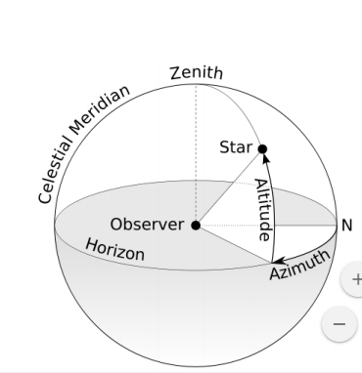

Figure : Local horizon coordinates

**Celestial equatorial coordinates**

Referenced to stars, independent of position on Earth and time of observation

* Axis: spin axis of the Earth
* Plane: celestial equatorial plane
* Angles: Declination (δ) between -90o and 90o, right ascension (α) between 0 and 24 hours (positive counter clockwise)
* Origin: centre of the Earth, vernal equinox for right ascension, celestial equator for declination 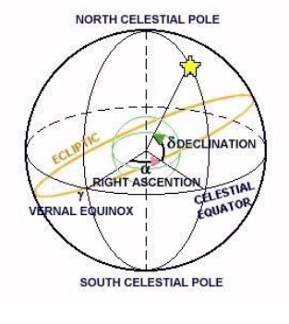

Figure : Celestial equatorial coordinates

**Ecliptic coordinates**

* Axis: Perpendicular to the ecliptic plane
* Plane: ecliptic plane
* Angles: ecliptic latitude (β) between 0o and 90o in the northern ecliptic hemisphere and -90o to 0o in the southern ecliptic hemisphere; ecliptic longitude (λ) from 0o to 360o starting from the vernal equinox and counter clockwise
* Origin: centre of the Earth

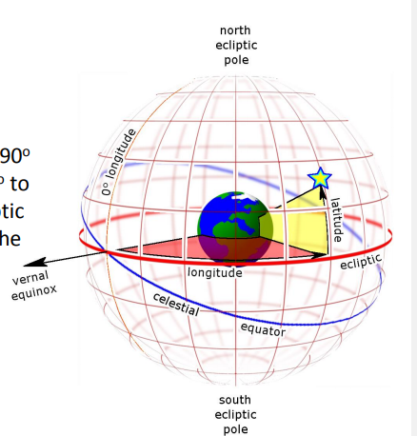

Figure : Elliptic coordinates

**Galactic coordinates**

* Axis: perpendicular to the galaxy
* Plane: plane of the galaxy
* Angles: galactic latitude (b) and galactic longitude(l) from 0o to 360o starting from the centre of the galaxy and clockwise
* Origin: Centre of the galaxy

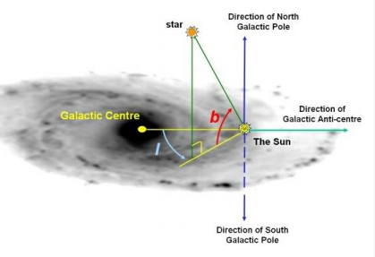

Figure : Galactic coordinates

## **1.2 Distance, luminosity, flux**

### **1.2.1 Angles:**

360o = 2π

1o = 2π/360o = π/180o or 1 rad = 180o/π

1 rad = 206265’’ (arcsec)

1o= 3600’’

**Definition of a parsec:**

1. The average distance from Earth to the Sun is 1.496x1011m = 1 AU
2. A parsec is a unit of length
3. The distance to a star is 1 parsec (pc) when its trigonometric parallax is 1’’ (arcsecond)

### **1.2.2 Trigonometric parallax**

Measures the change in apparent position of a star with the respect to the background stars, as the Earth moves by six months around its orbit. (half orbit).

The assumption is that the background stars are fixed

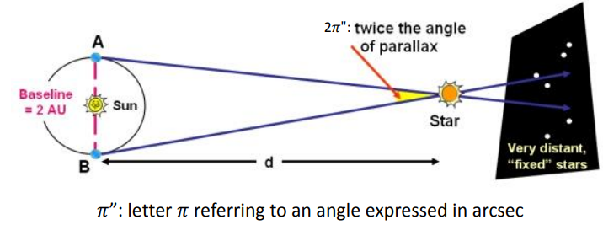

Figure : Trigonometric parallax

From the definition of parallax:

$tan\left(π\right)=\frac{opp}{adj}=\frac{1 Au}{d}$

Then for small angles, the parallax is defined as

$π^{''}=\frac{1}{d\left(parsec\right)}$

And when $π^{''}$ = 1’’, d = 1 parsec = 206265 AU: this is the definition of a parsec

Also 1 parsec = 3.086x1016m

### **1.2.3 Examples**

1. Proxima Centauri has a parallax of $π^{''}$ = 0.7723 arcsec, find the distance to the star in parsec and AU:

In parsecs:

$d=\frac{1}{0.7723 (arcseconds)}$ = 1.294 parsec

In AU:

d = 1.294 parsec x 206265 = 266906.91 AU

In m:

d = 266906.91AU x 1.496x1011m = 3.99x1016m

1. Alpha Centauri A and B has a parallax of $π^{''}$ = 0.7421 arcsec, find the distance to the stars in parsec and AU

In parsecs:

$$d=\frac{1}{0.7421(arcseconds)}=1.348 parsec$$

In AU:

d = 1.348parsec x 206265 = 277947.72 AU

In m:

d = 277947.72AU x 1.496x1011m = 4.16x1016m

### **1.2.4 Luminosity flux and intensity**

Intrinsic brightness is the measure of how much light the star emits at a given time whereas the apparent brightness is a measure of how much light per unit area enters the aperture of a telescope (or eye) in a given time.

#### **Luminosity**

Energy per unit time (intrinsic brightness)

$L=\frac{∆E}{∆t}$

Measured in Watt (W)

The luminosity of the Sun is Lʘ = 3.86x1026W

#### **1.2.4.2 Flux (Apparent brightness)**

Energy per unit time passing through a unit area per unit frequency

$$f=\frac{∆E}{∆tΔA∆ν} \left[Wm^{-2}{Hz}^{-1}\right]$$

Where A is an area, and ν is the frequency of photons.

Also, the flux, F, of light through the sphere of radius, d, is the luminosity divided by the sphere’s area:

$$F=\frac{L}{4πd^{2}} \left[Wm^{-2}\right]$$

**Examples**

1. The Sun’s flux at the Earth’s location is
$$F=\frac{L_{⊙}}{4π\left(1AU\right)}=\frac{3.86x{10}^{26} W}{4π(1.496x{10}^{11})^{2}m}=1370 Wm^{-2}$$

2. The flux of Sirius is F=1.2x10-7 Wm-2. The parallax of Sirius is d = 2.637Pc. What is the luminosity of Sirius?

L=4πd2F

L= 4π (2.637x3.086x1016)2x1.2x10-7 = 1028W = 26Lʘ

#### **Intensity**

Energy per unit time passing through a unit area per unit frequency per unit solid angle in the direction θ:

$$I\left(θ\right)=\frac{ΔE}{ΔtΔAΔυΔΩ} Wm^{-2}{Hz}^{-1}{sr}^{-1}$$

Where Ω is the solid angle expressed in steradian (sr)

Definition

1 sr is the solid angle cut out by an area r2 on the surface of a sphere of radius r.

Note that for the total surface, 0< Ω <4π

### **1.2.5 Magnitude system**

Greeks defined an astronomical magnitude system such that the brightest stars were 100 times brighter than the faintest. The brightest stars were defined as first magnitude (101), and the faintest stars were defined as sixth magnitude (106).

Small numerical values are therefore bright, larger are faint.

Sirius has a magnitude of -1.46

#### **1.2.5.1 Apparent brightness (m)**

The apparent magnitude, m, of a star measures the flux from a star at the Earth and is defined as

**m = -2.5log(f) + constant** Where f is the flux at frequency ν

**Example**

Consider two apparent magnitude, m1 and m2, such that m2-m1 = 5. Find the flux ratio for those two stars:

m1= -2.5log(f1)+K

m2= -2.5log(f2)+K

m2-m1 = 5 = -2.5log(f2) + 2.5log(f1)

m2-m1= 5 = 2.5log(f1/f2)

2=log(f1/f2)

f1/f2 = 102 = 100 f1 = 100f2

#### **1.2.5.2 Absolute brightness (M)**

The apparent brightness, m, of stars varies because they span a vast range of distances. To compare their intrinsic brightness, we define absolute magnitude, M. this is the magnitude that a star would have if it were 10 parsecs away from the Sun:

**M = -2.5log(f10) + constant**

Where f10 is the flux estimated at 10 parsecs

This leads to the following equation:

**m = M + 5log(d) – 5**

Where d is measured in parsecs

**Example**

Proxima Centauri is at d = 1.295 pc, find the absolute magnitude (m = 10.7)

m = M + 5log(d) – 5

m-M= 5log(d)-5

-M= 5log(d)-5-m

M= -5log(d)+5+m

$$M=-5\log\left(1.295\right)+5+10.47=14.91$$

#### **1.2.5.3 Distance Modulus**

The distance modulus is a logarithmic measure of the distance to a star, m-M:

m – M = 5log(d/10) Where d is in parsec

Table

|  |  |  |  |
| --- | --- | --- | --- |
| Name | m | M | m-M |
| Sirius | -1.5 | 1.4 | -2.9 |
| Alpha Centauri A | 0.0 | 4.4 | -4.4 |
| Alpha Centauri B | 1.4 | 5.8 | -4.4 |
| Proxima Centauri | 10.7 | 15.1 | -4.4 |
| Moon | -12.74 |  |  |
| Sun | -26.75 | 4.83 | -31.58 |

Least bright object at about +25 in apparent magnitude

In practice, we define (and measure) magnitudes in a specific wavelength range. The most common is the Johnson UBV system (a particular system of magnitudes)

Table

|  |  |  |  |  |  |  |  |  |  |  |
| --- | --- | --- | --- | --- | --- | --- | --- | --- | --- | --- |
|  | Ultraviolet | Blue | Visible | Red | Infrared |  |  |  |  |  |
| Band | U | B | V | R | I | J | K | L | M | N |
| Wavelength (μm) | 0.35 | 0.44 | 0.55 | 0.64 | 0.79 | 1.25 | 2.2 | 3.45 | 4.65 | 10.3 |

We use the notation MB­ or B to describe the absolute magnitude of a star in the B-band.

In the Johnson UBV system, the difference between B and V band magnitudes is called the colour index. Because hot stars are bluer than cooler red stars then they will be brighter in B band than in V band.

By definition, B - V= 0 for Vega

B-v<0 for hotter stars than Vega (T>10000K)

B-V>0 for cooler stars than Vega

[B-V]cool > [B-V]hot

We can exploit this further to measure what is called the bolometric magnitude, Mbol, which is the absolute magnitude that represents the total energy of a star summed over all wavelengths.

We therefore need measurements of the flux of stars across all wavelengths, e.g., satellite measurements such that the radiation that is absorbed by our atmosphere can be included (EUV for instance)

The bolometric flux is the flux f(λ) integrated over all wavelengths:

$f_{bol}= \int_{λ→0}^{λ→∞}{f\left(λ\right)dλ}$

The apparent bolometric magnitude, mbol, is the apparent magnitude that represents the total energy output of a star summed over all wavelengths:

mbol = -2.5log(fbol) + constant

The absolute bolometric magnitude is:

Mbol = -2.5log(f10,bol) + constant

Where f10,bol is the total flux at a distance of 10 pc.

In practice, bolometric magnitudes are hard to measure, and so we use theoretical models of stars to create a bolometric corrections:

BC = mbol – mV = Mbol – MV

The distance of the modulus is still given by

mbol – Mbol = 5log(d) – 5

This is now possible to derive a relationship between the absolute bolometric magnitude of a star and that of the sun, against luminosity:

$M_{bol}^{star}- M_{bol}^{⊙}= -2.5\log\left(\frac{L^{star}}{L^{⊙}}\right)$

## **Blackbody Radiation**

Definition: A perfect absorber and perfect emitter of electromagnetic radiation is called a black body

A blackbody spectrum therefore:

* Emits radiation at all wavelengths
* Hotter black bodies emit more radiation than cooler black bodies (across all wavelengths)
* The spectrum of a hotter black body peaks at shorter wavelengths (higher frequencies) than a cooler black body
* Reminder: for EM radiation,

Speed = frequency x wavelength

C = ν x λ

In 1900, Max Planck postulated that EM radiation is emitted in discrete quantum, with energy proportional to the frequency, E=hν.

Planck then formulated an equation for the spectrum of a perfect black body:

$B\left(ν,T\right)=\frac{2hν^{3}}{c^{2}}\frac{1}{{(e}^{\frac{hν}{kT}}-1) }$

Where h is Planck constant, c is the speed of light, T is the temperature, and k is the Boltzmann constant.

This is the Planck distribution 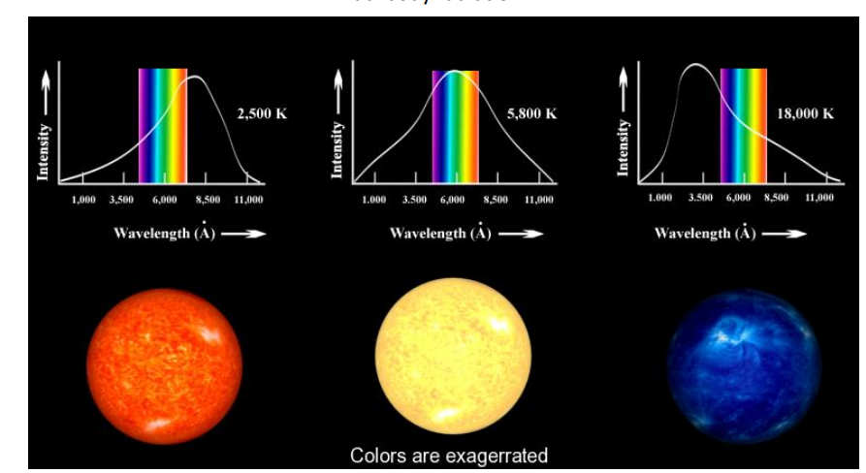

Figure : Planck distribution

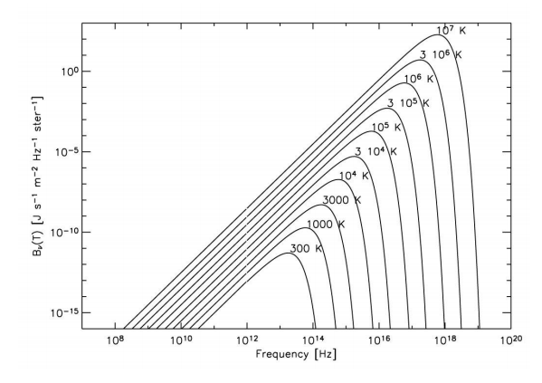

Figure

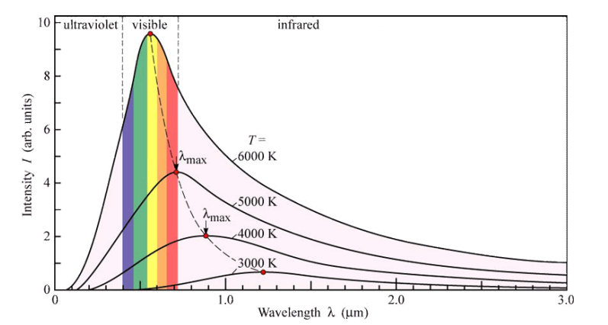

Figure

### **1.3.1 Wien’s law**

There is a relationship between the temperature of the black body and the wavelength at the maximum intensity:

$$λ_{max}= \frac{2.893x{10}^{-3}}{T}$$

In the low frequency limit (hν << kT), the Planck’s distribution can be approximated by:

$$B_{ν}=\frac{2kT}{c^{2}}ν^{2}$$

This is the Rayleigh-Jeans limit.

In the high frequency limit (hν >> kT), the Planck’s distribution can be approximated by:

$$B_{ν}= ν^{3}e^{\frac{-hν}{kT}}$$

This is the Wien limit.

### **1.3.2 Stefan-Boltzmann law**

The flux emitted by a black body, when totalled over all wavelengths is proportional to temperature to the fourth power:

FTotal  T4

Or FTotal = σ T4

Where σ is Stefan’s constant and σ = 5.669 x 10-8Wm-2K-4

Thus, we can re-write the luminosity of a star, L, of radius, R, that emits as a perfect black body:

$L=4πR^{2}σT^{4}$

The temperature estimated is called the effective temperature Teff of the star.

# **Chapter 2 – Stars and their evolution**

## **2.1 The Hertzsprung-Russell (HR) diagram**

### **2.1.1 Spectral classification**

The strength of absorption lines superimposed on the EM spectrum of a star depends on the temperature of the star. It also depends on the abundance of the absorbing atoms.

For stars cooler than 10,000K, only a small fraction of the H atoms have electrons excited to level n=2 or higher. For stars hotter than 10,000K, the H atoms are ionised and for these reasons the Balmer lines are stronger.

Therefore, the strength of the Balmer lines are independent of the abundance of H but mostly of temperature

Hα: 656.3nm; Hβ:486.1nm; Hγ: 434.1nm

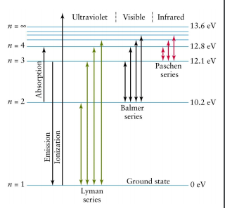

Figure

The spectral classification itself:

In the early 20th century, approximately 105 stars were classified according to the strength of the Balmer lines in their individual spectrum.

A type A star has the strongest Balmer lines, type B the next strongest, and so on. Work done by Annie Cannon (around 1912).

Table

|  |  |  |  |  |
| --- | --- | --- | --- | --- |
| Spectral class | Colour | Surface Temp. | Comment | Example |
| O | Blueish-white | >30000 | Relatively low absorption lines. Lines of ionised He and other element present. H lines appear weak | Naos |
| B | Blueish-white | 11000-30000 | Line of neutral He. H-lines more pronounced than for O-types | Rigel |
| A | Blue to white | 7500-11000 | Strong Hα lines. Also, lines of single ionised Mg/Fe/Ca. Some weak neutral metal | Sirius |
| F | Blue to white | 6000-7500 | H-lines weaker than A-types. Lines of ionised metal present | Procyon |
| G | White-yellowish | 5000-6000 | Lines of ionised Ca most prominent. Some lines of ionised metals | The Sun |
| K | Yellow-orange | 3500-6000 | Lines of neutral metal dominates | Aldebaran |
| M | Red | <3500 | Strongest lines of neutral metals | Betelgeuse |

Stars are assigned a spectral type depending on their spectra, which relates to a star’s surface temperature. An extended classification exists for L type (1300-2500K) and T-type(<1300K) dwarf stars.

The system is subdivided into 10 divisions from 0 to 9, E.G. F0, F1, F2, F3, F4, F5, F6, F7, F8, F9 with F1 being hotter than F2, and so on.

Extended classification: luminosity classes depending on the width of spectral lines, the narrowest lines are of class I and then increase to class VI at a given temperature.

Table

|  |  |
| --- | --- |
| Luminosity class | Star size |
| I | Supergiant |
| II | Bright giant |
| III | Giant |
| IV | Subgiant |
| V | Dwarf |
| VI | Subdwarf |

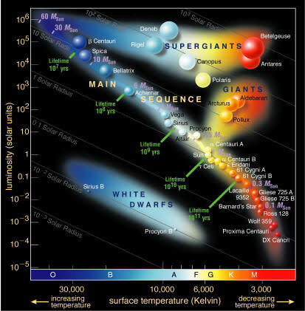

Figure : Hertzsprung-Russell diagram

### **2.1.2 Interpreting the HR diagram**

HR diagram plots luminosity versus colour/surface temperature, these two characteristics have proved extraordinarily effective in understanding the properties and life cycle of stars.

By 1910s, sufficient data relating luminosity and temperature could be gathered allowing Ejnar Hertzsprung (1911) to create a plot of absolute magnitude versus their spectral type. Henry Russell (1913) produced a plot of absolute magnitude of nearby stars and their spectral type, resulting in the HR diagram.

**Main sequence:**

* 90% of stars
* (stable) stars are found on a line form upper left to lower right
* Hotter stars are brighter
* Cooler stars are dimmer
* The sun les approximately in the middle of the MS

**Red Giant Stars:**

* Upper, right hand corner
* Big, bright, and cool

**Red giant/Supergiant:**

* More luminous

**White Dwarf Stars:**

* Lower left-hand corner
* Small, dim, and hot

These classifications (MS, white dwarf, red giant, supergiant) also indicate types of stars and stages in their evolution.

### **2.1.3 Stellar radius**

Recalling that the Stefan-Boltzmann law links luminosity, radius, and effective temperature. If we know the luminosity and temperature of a star, then we can deduce its radius.

* Small stars will have low luminosities for a given temperature (bottom of the HR diagram)
* Stars with low surface temperatures must be very large for a given luminosity (top-right corner of the HR diagram)
* Giant/supergiant must be big/large radii
* White dwarf must be small (in radii)

**Example 1**

The range of stellar luminosities suggest that the most luminous stars are larger than the sun. For instance, Betelgeuse has a luminosity L = 100,000Lʘ and Teff = 3600K. Assuming that Betelgeuse acts as a black body, find the ratio of radii between the star and the Sun (Tʘeff = 6500K).

Solution: $L=4πR^{2}σT^{4}$ So $R^{2}=\frac{L}{4πσT^{4}}$ So $R=\sqrt{\frac{L}{4πσT^{4}}}$

Betelgeuse: $R_{*}= \sqrt{\frac{\left(3.846x{10}^{26}\right)100,000}{4π\left(5.669x{10}^{-8}\right)\left({3600}^{4}\right)}}= 5.67x{10}^{11}m$

The Sun: $R_{⊙}= \sqrt{\frac{3.846x{10}^{26}}{4π\left(5.669x{10}^{-8}\right)\left({6500}^{4}\right)}}= 5.45x{10}^{8}m$

Ratio of the radii:

$\frac{5.67x{10}^{11}m}{5.45x{10}^{8}m}=1040.37$

So, R* = 1040.37Rʘ

**Example 2**

Suppose that the radius of the Sun increased by a factor of 4, but the rate of power generation by internal fusion remained the same (fixed L). How would the surface temperature change?

L* = Lʘ

R* = 4Rʘ

### **2.1.4 Spectroscopic parallax**

* Recall the “parallax” or trigonometric parallax seen before for relative short distance
* If a star is on the MS, there is a definite relationship between spectral types and absolute magnitude.
* Observe spectral type and observe apparent magnitude, m
* Read absolute magnitude on HR diagram, M
* With m and M, calculate the distance d following the definition of distance modulus

m – M = 5log(d/10)

**Example**

Measuring the spectrum of a star, we find its spectral class being F2V. Observing the star brightness, we find the apparent magnitude of m = 9.5. Find d

m – M = 5log(d/10)

M = 4

m – M = 5.5

5.5 = 5log(d/10)

d/10 = 101.1

d = 125 pc

### **2.1.5 Key characteristics**

1. Stars are scattered all over the HR diagram, but ~90% lie in a diagonal band (MS)
2. The radii of stars increase approximately perpendicular to the MS
3. A few stars (<10%) lie above the MS red-ward: red giants
4. A few stars lie above the red giant: the Supergiants
5. Another group of faint stars below the MS: White dwarfs
6. Empirical data also shows that MS is also a mass sequence

### **2.1.6 Mass-radius relation**

For stars **on the MS,** a good empirical relation between mass and radius can be established:

$$\frac{R}{R_{ʘ}}=1.06\left(\frac{M}{M_{ʘ}}\right)0.945 M<1.66M_{ʘ}$$

$$\frac{R}{R_{ʘ}}=1.33\left(\frac{M}{M_{ʘ}}\right)0.555 M>1.66M_{ʘ}$$

### **2.1.7 Mass-Luminosity relation**

For stars **on the MS**, a good empirical relation between mass and luminosity can be established:

$$\frac{L}{L_{ʘ}}=0.35\left(\frac{M}{M_{ʘ}}\right)2.62 M<0.7M_{ʘ}$$

$$\frac{L}{L_{ʘ}}=1.33\left(\frac{M}{M_{ʘ}}\right)3.92 M>1.66M_{ʘ}$$

Often the relation between mass and luminosity on the MS is approximated by a single power law:

L ∝ M3.5

Mass is a fundamental characteristic of stars, but difficult to measure. Essentially, all the mass measurements that we have are from stars in binary systems.

### **2.1.8 Stellar age/lifetime**

Can we use the HR diagram to estimate the lifetime/age of stars?

Table

|  |  |
| --- | --- |
| Energy source for Sun | Lifetime (years) |
| Chemical energy (e.g., coal) | ~104 |
| Thermal energy (e.g., heat content) | ~107 |
| Gravitational contraction | ~108 |
| Thermonuclear fusion (H -> He) | ~1011 |

Compared to the Earth age of 5x109 years, the source of energy in stars has to be thermonuclear fusion.

Assumption:

Amount of fuel and stellar mass (efficiency of 10%)

or

“How fast it burns” and stellar luminosity (rate of energy release)

Lt ∝ M

t = B M-2.5

Table

|  |  |
| --- | --- |
| Mass (Mʘ) | Lifetime (years) |
| 60 | 4x105 |
| 30 | 2x106 |
| 10 | 3x107 |
| 3 | 6x108 |
| 1 | 1010 |
| 0.3 | 2x1011 |
| 0.1 | 3x1012 |

Using -2.5 power law index for all stars on the MS

Age of Earth: 5x109 years

Age of the universe: 13.6x109 years

For stars **on the MS,** a good approximation of lifetime is:

$$τ∝\frac{M}{L}∝M^{-1.62} M<0.7M_{ʘ}$$

$$τ∝\frac{M}{L}∝M^{-2.92} M>0.7M_{ʘ}$$

Higher mass stars live shorter lives. For instance, Sirius A which has mass more than twice that of the Sun, will have a lifetime less than 1/8 as long before running out of fuel.

Overall, stars are luminous spheres of plasma held together by their own gravity, and are described by their mass, radius, luminosity, and temperature.

## **2.2 Physics principles: energy source and transport**

How to build a star?

“Vogt-Russell” theorem for spheres of water: sphere of water have several properties (mass, density, volume, radius, surface area), however we can reduce these properties to one or two key parameters.

Assuming that we know the density and radius, we can deduce the mass, the volume, and the surface area. For stars, we can extend this principle to say that there is a primary way to build a star with a given mass and chemical composition.

### **2.2.1 Hydrostatic equilibrium**

A hydrostatic equilibrium, i.e., the balance between the pressure forces and gravity, is satisfied to a high degree of accuracy in stars since, in general, we do not see their radii rapidly changing.

Pulsating stars/variable stars do have trouble to maintain hydrostatic equilibrium.

Gravitational forces pull everything in (centripetal force), and pressure forces push everything out (centrifugal force).

Example: Hydrostatic equilibrium with constant gravity (on Earth)

Σ F = 0

The two forces to consider are the gravitational force:

Fg = er

And the pressure forces

Fp = er

Where M is the total mass of the star, ρ is the local mass density and p is the plasma pressure.

The hydrostatic equilibrium is then given by:

$\frac{dp}{dr}= -\frac{GM\left(r\right)ρ}{r^{2}}$

The mass, M, inside a sphere of radius is 4/3 πr3, leading to the following equation:

$\frac{dp}{dr}= -\frac{4}{3}πGρ^{2}r$

Case 1: constant mass density with ρ(0) the pressure at the centre, and ρ(R) the surface pressure.

Find the expression for the pressure at the centre and for the temperature at the centre.

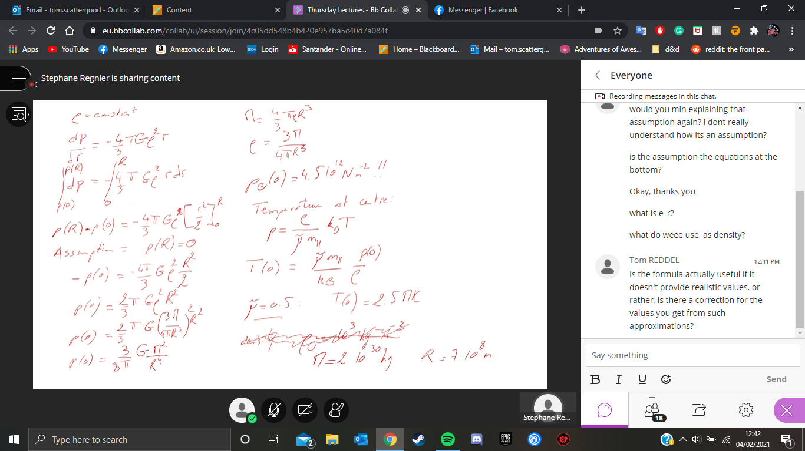

#### **2.2.1.1 Ideal gas law:**

$$p=\frac{ρ}{μm_{H}}k_{B}T$$

Where mH is the mass of a proton, and μ is the mean atomic weight.

The chemical composition of an atmosphere can be expressed in terms of the following mass fractions:

$$X=\frac{ρ_{H}}{ρ};Y=\frac{ρ_{He}}{ρ}; Z= \frac{ρ_{metal}}{ρ}=1-X-Y$$

(metal = atomic number greater than 2).

For a neutral gas of H (X=1), its mean atomic weight is 1.

For a fully ionised gas of H (X=1), its mean atomic weight is 0.5 since one electron is freed from each atom.

For a neutral gas of He (Y=1), its mean atomic weight is 4.

For a fully ionised gas of He (Y=1), its mean atomic weight is 4/3 since two electrons are freed from each atom.

For a fully ionised plasma with 70% of H, 28% of He and 2% of metals, its mean atomic weight is 0.62

Stellar material is in a plasma state – all but the most tightly bound electrons have been stripped from their atoms. This allows a greater compression, without deviating from the ideal gas law.

#### **2.2.1.2 What sort of astrophysical systems can be described by the hydrostatic equilibrium?**

Where there is little interaction between the particles: “gas at low temperature”, and low densities then:

* Stellar matter over the majority of its lifetime
* Interstellar matter, nebulae
* Systems of particles in stellar clusters

In stellar interior, radiation is in thermal equilibrium with matter, and photons exert a pressure too:

Pgas = nkBT and Prad =

So, the radiation pressure can be neglected in MS stars, but important in high density stars (white dwarfs)

### **2.2.2 Source of energy: nuclear fusion**

Coulomb repulsion force: two protons are moving away from each other and are affected by the long-range Coulomb force with a potential energy given by:

$$U=\frac{e^{2}}{4πϵ_{0}r}$$

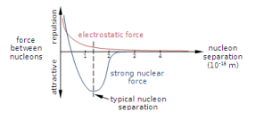

Figure : Coulomb barrier

For the strong interaction force to overcome the Coulomb force, the kinetic energy should be larger than the potential energy of the Coulomb force.

U = 1.4MeV for a range of 10-15m

as typical kinetic at the centre of the sun

However, the thermonuclear fusion can still happen by quantum mechanical tunnelling.

Total mass of a nucleus, m(Z, N) is less than the mass of its constituent nucleons, i.e., Z protons and N neutrons. This mass loss implies an energy release called the binding energy which is given by:

$$Q\left(Z,N\right)=[Zm_{p}+Nm_{n}-m\left(Z,N\right)]c^{2}$$

Light nuclei fuse whilst heavy nuclei split.

Nuclear reaction rates:

Is determined by:

* How close the nuclei can get together
* Probability of reaction to occur

The proximity of nuclei depends on if the amount of energy is sufficient to overcome the Coulomb barrier. It is also a function of the cross-section for P-P fusion

$<N_{pp}> = \int_{0}^{∞}{N_{pp}}\left(E\right)f\left(E\right)dE$

Integrated over all kinetic energies (Maxwell-Boltzmann distribution)

And where Npp is the total number of P-P fusions per unit volume per unit time:

$N_{pp}=\frac{1}{2}n_{p}^{2}σ_{pp}ν$

With a mean free path of:

$ι_{pp}=\frac{1}{n_{p}σ_{pp}}$

#### **2.2.2.1 Gamow energy**

Probability of penetrating the Coulomb barrier

$p_{pen}=\exp\left(-{\left(\frac{E_{G}}{E}\right)}^{\frac{1}{2}}\right)$ With E = energy of the particle

EG = Gamow energy

EG = 2Mrc2 (πα ZAZg)2 between two particles A and B

mr = reduced mass = $\frac{{(M}_{A} x m_{B}) }{\left(m_{A}+m_{B}\right)}$

α =1/137

ZA, ZB = charge of particles

**Example 1:** Collision between two protons (11H)

mr = (mAxmB)/(mA+mB) = ½ mp = 8.365x10-20kg

ZA = ZB = 1

EG = 2mrc2(πα x1x1)2 = 7.907x10-19J

**Example:** Collision between two Helium atoms (32He)

mr = (mHexmHe)/(mHe+mHe) = 3/2 mp = 3mp

ZA = ZB = 2

EG = 2mrc2(πα x2x2)2 = 3.716x10-12J

#### **2.2.2.2 PP-Chains**

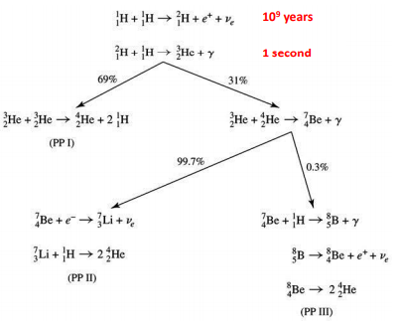21H: deuterium

Figure : P-P chains

42He: Helium/alpha particles

The PP-I chain is the dominant chain for temperatures between 10-15MK, 2% of energy is lost due to neutrinos.

The PP-II chain is the dominant chain for temperatures between 15-23MK, this includes Li burning, 4% of energy is lost due to neutrinos.

The PP-III chain is the dominant chain for temperatures above 23MK, 28.3% if energy lost is due to neutrinos

#### **2.2.2.3 CNO cycle**

First describe by Bethe in 1939, overall conversion of 4 protons to an alpha particle, which is accomplished by catalytic reaction via, Nitrogen, Carbon and Oxygen.

For the Sun, it accounts for about 1.7% of the heat generation, but is highly important for hotter stars.

Carbon is generated by the triple alpha process

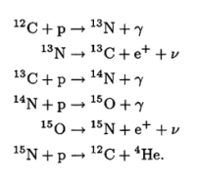

Figure : The CNO cycle

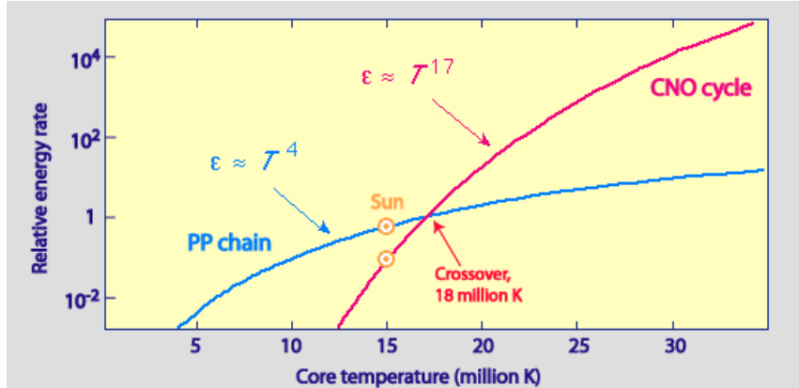

Figure : Comparison between energy production for PP-1 chain and the CNO cycle

#### **2.2.2.4 Triple-alpha process**

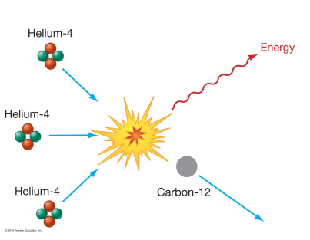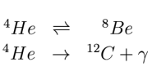

The process also produces some Oxygen

#### **2.2.2.5 Other mechanisms**

### **2.2.3 Transport of energy**

#### **2.2.3.1 Luminosity gradient**

Energy is transported from the core of stars, radially outwards. Heat at the centre of the star is due to nuclear fusion/reaction

How does energy get out?

The equation of energy generation is given by the luminosity gradient:

$\frac{dL}{dr}=4πr^{2}ρε$

Where ε is the rate of energy production

#### **2.2.3.2 Conduction**

Conductive energy transport occurs when the thermal motion of atoms or molecules causes them to collide with neighbouring atoms or molecules, resulting in the transfer of kinetic energy.

Thermal conduction is important in the heating of coronal loops in the solar atmosphere (gradients of temperature).

Conduction can be disregarded in gas/plasma in stellar interiors, except for high density stars such as white dwarfs.

#### **2.2.3.3 Radiation**

Consider a thin spectral shell. The inner radius is r and outer radius is r + dr. The temperature at the inner surface of the shell is T; and the temperature of the outer shell is T + dT.

The radiation pressure at the inner surface of the shell is

$p_{rad}\left(r\right)=\frac{a}{3}T^{4}$

Where a is the radiation constant (a = 7.56x10-16J m-3 K-4)

The radiation pressure at the outer shell is

$p_{rad}\left(r+dr\right)=\frac{a}{3}({T+dT)}^{4}$

The radiation force exerted on the shell will be the difference in radiation times the area:

$DF_{rad}=\left[p_{rad}\left(r\right)-p_{rad}\left(r+dr\right)\right]4πr^{2}$

${dF}_{rad}=-\frac{16π}{3}{ar^{2}T}^{3}dT$

The optical depth of a thin spherical shell is given by:

$dτ= -ρ\left(r\right)κ\left(r\right)dr$

Where κ(kappa) is the opacity of the medium.

$$dF_{rad}= -ρ(r)κ(r)F_{rad}dr$$

$\frac{dF_{rad}}{dr}= -ρ(r)κ(r)F_{rad}$

Example of constant density

If the optical depth < 1, the medium is optically thin (the probability that a photon will be absorbed is small).

If the optical depth > 1, the medium if optically thick

As the luminosity L(r) is the total rate at which photons carry energy through the shell:

$dF_{rad}=\frac{L\left(r\right)}{c}dτ= -\frac{L\left(r\right)}{c}ρ(r)κ(r)dr$

We thus get the equation of radiative energy transport:

$\frac{dT}{dF}\frac{dF}{dr}= \frac{dT}{dr}=\frac{3ρ\left(r\right)κ\left(r\right)L(r)}{16πacT^{3}r^{2}}$

* Relates temperature gradient to opacity
* Regulates the flow of radiation radially outwards from the stellar core
* Photons diffuse outwards in a random walk of 103 years (with a mean free path of about 1cm)

#### **2.2.2.4 Convention**

Where will convection normally occur?

* Places with large temperature gradients. Highest temperature gradients found in cores of high mass stars (about 1.5Mʘ, and where the CNO cycle dominates)
* The other important quality is the adiabatic index, γ. In outer envelope of low mass stats, the material may not be fully ionised. This will lead to an increase in the specific heat since the majority of energy goes into ionising the material without increasing the temperature.

The adiabatic index will then tend to 1 (nearly isothermal) instead of 5/3 and will make convection easier.

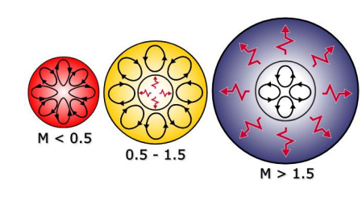

For the Sun:

* Supergranulation is interpreted as the signature of convection in the interior
* Granulation is interpreted as convection in a shallow layer, may be linked to local dynamo action

### **2.2.4 Star’s modelling**

Summary of equations of stellar structure

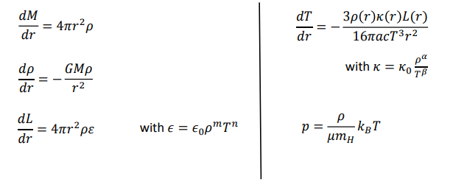

dp

We need boundary conditions:

* At r=0, M=0 and L=0
* At r=R (surface of the star), M = Mtotal­, temperature and density are zero (negligible compared to core values).

**Additional constraints**

1. Conditions inside star and inside core must be compatible with adequate nuclear reaction rates
2. Parameters required in a.must be compatible with a stable stellar structure
3. Energy generated at the centre must be able to reach the surface within a time scale which is small compared to the age of the universe

The numerical model gives:

$$L=2.4x{10}^{26}(\frac{M}{M_{⊙}})^{4.515} J s^{-1} \\ R=6.15x{10}^{26}(\frac{M}{M_{⊙}})^{0.265} J s^{-1}$$

This gives a radius for the Sun that turns out to be too small and a luminosity too large

These results are good but not great, especially for the following (strong) assumptions

* Radiative pressure
* Convection
* Empirical formulae for the energy and opacity
* Assuming T=0 at r=R
* Neutrino

General comments on stellar structures

1. High mass stars have central region with substantial energy for convection. Energy generation by CNO cycle. Material in deep interior is well mixed: important evolutionary consequences
2. Lower mass stars have their energy generated by the P-P chain reactions. Outer region is convective
3. Some relationships for MS stars:

L α M2.5; R α M0.7; Tcore α M0.3; Tsurface α M0.65

1. Lower bound on mass: mass of stars for which no consistent solution of the equations can be obtained. Such objects will just cool down and die without tapping a nuclear energy source. This critical mass is about 0.1Mʘ
2. Regions of the Hr diagram that cannot be covered by MS stars: giants, supergiants, white dwarfs, neutron stars

## **Star’s formation**

### **2.3.1 Observational evidence**

The association of O and B stars with the gas and dust cloud in spiral arms of galaxies suggests that stars are formed from clouds of gas and dust.

Models of star formation are still sketchy, but the main ingredient is the gravitational collapse of a molecular cloud, a mass of gas exceeding a critical density begins to collapse under the gravitational force.

The criterion of instability is tff < tpress

Where:

$$t_{ff}=(\frac{3π}{32Gρ_{0}})^{\frac{1}{2}}$$

Derivation:

Mass: M = $\frac{4}{3}πρR^{3}$

NII: F= ma

$$m \frac{d^{2}r}{dt^{2}}=\frac{-GMm}{r^{2}}=-\frac{4}{3}Gπρ\frac{R^{3}}{r^{2}}$$

$\frac{d^{2}r}{dt^{2}}=\frac{dν}{dt}=\frac{dr}{dt}\frac{dν}{dr}=\frac{νdν}{dr}$

$\frac{νdν}{dr}=-\frac{4}{3}πGρ\frac{R^{3}}{r^{2}}$

$\frac{1}{2}ν^{2}= \int{-\frac{4}{3}πGρ\frac{R^{3}}{r^{2}} dr}=\frac{4}{3}πGρR^{3}\left[\frac{1}{r}\right]=\frac{4}{3}πGρR^{3}+C$

At r = R, ν = 0, C = $-\frac{4}{3}πGρR^{2}$

$$\frac{1}{2}ν^{2}=\frac{4}{3}πGρR^{2}\left[\frac{R}{r}-1\right]$$

$$ν={\left(\frac{8}{3}πGρR^{2}\left[\frac{R}{r}-1\right]\right)}^{\frac{1}{2}}$$

$$t_{collapse }= \int{|dt|}= \int{\frac{dr}{|ν|}}= \int_{0}^{R}{\frac{dr}{\sqrt{\frac{R}{r}-1}}× {\left(\frac{3}{8πGρR^{2}}\right)}^{\frac{1}{2}}}$$

u = r/R, $\left[\begin{matrix}u=0 \\ u=1\end{matrix}\right]$

du = dr/R

u = sin2(α),

du = 2cos(α)sin(α)dα

=

=

=

And

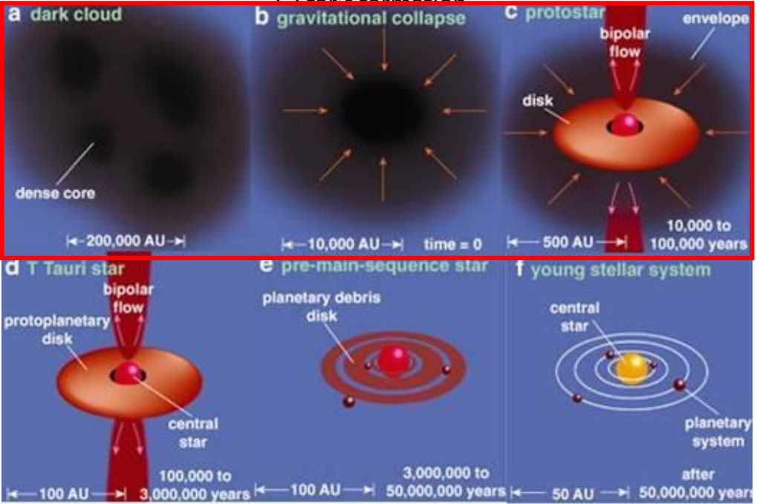

Figure : Star formation process

### **2.3.2 Stages of evolution**

* Giant molecular cloud (H2): cloud of dust and gas, full of H in molecular form (H2). External trigger: shock wave (supernovae explosion), spiral arms, collision
* At certain location, where the mass > Jeans mass, runaway/gravitational collapse. Formation of smaller clouds
* Gravitationally collapsed gas radiates away the energy gained by release /reduction of stored gravitational potential (see Virial theorem)
* Even if the initial rotation is small (angular momentum), the cloud will collapse into a disk (protoplanetary disk)
* A protostar is formed: slowly rotating star with no thermonuclear reactions formed by loss of angular momentum

### **2.3.3 Jeans length and mass**

$$r_{j}=(\frac{3πγk_{B}T}{32Gρ_{0}μm_{p}})^{\frac{1}{2}}$$

With μ (mean atomic weight) = 2 and $γ$ (adiabatic index) = 7/5, the Jeans length can be expressed as follows:

$$r_{j}=2000 AU {\left(\frac{T}{10 K}\right)}^{\frac{1}{2}} {\left(\frac{ρ_{0}}{3x{10}^{-15}kg m^{-3}}\right)}^{-\frac{1}{2}}$$

This gives a mass within a sphere of radius rj:

### **2.3.4 Virial theorem**

The relation between total thermal energy (U) and total gravitational potential (Ω)

$$2U+ Ω=0$$

Twice the thermal energy of a star = total gravitational potential energy (in absolute value)

Conclusion: A star with no internal energy generation composed of a perfect gas will either:

* 1. Contract as it radiates
  2. Radiate as it contracts

Half of the energy is liberated by the contraction, i.e., half is radiated away, half is stored.

The star contracts; potential energy increase (1/r) in magnitude; the total potential energy becomes more negative; U increases; the star gets hotter

The star heats up; U increases; the total potential energy gets more negative; increases in magnitude; the star becomes more tightly bound; the star radius decreases

## **Journey towards and away from the main sequence**

### **2.4.1 Pre-main sequence evolution**

From protostars to main sequence stars

Forbidden zone with less than 0.08 solar mass (brown dwarfs)

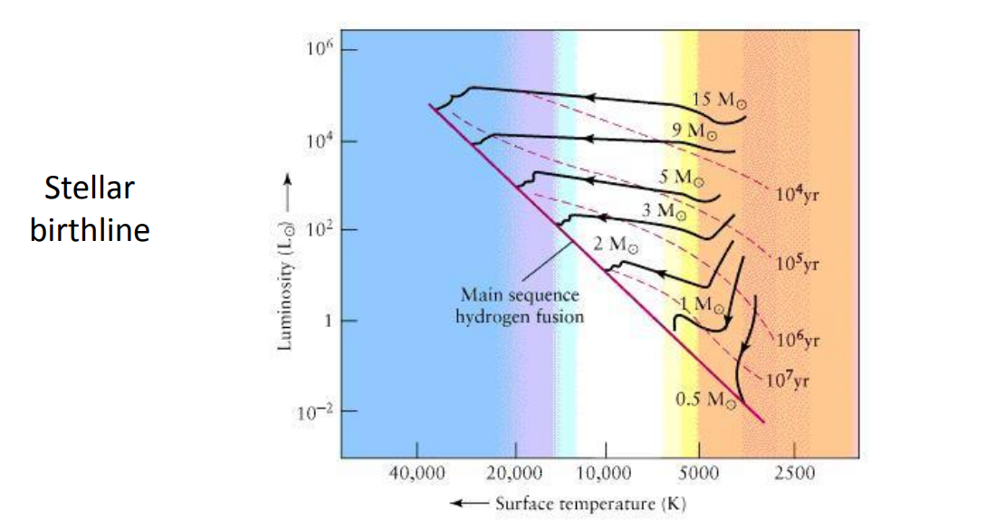

Hayashi track: almost vertical track (constant surface temperature) for relatively low mass stars (<0.5 solar mass). Stars are fully convective

Figure

End of the vertical branch = start of the thermonuclear fusion via pp chain or CNO cycle.

Henyey track: horizontal evolutionary track (constant luminosity)

The continuous gravitational collapse of the protostar leads to bipolar jets (ejected material from the interaction between the protostar and the disk) and the formation of a T-Tauri star (variable star still contracting).

Stars may stop contracting when a radiative zone is developed or when nuclear fusion starts in the core.

### **2.4.2 Lifetime on the main sequence**

The nuclear time scale is given by

$$τ=\frac{fεMc^{2}}{L}$$

Where f is the fraction of nuclear fuel available and $ε$ is the efficiency of the energy production

Estimate lifetime on the main sequence:

$$t_{MS} α\frac{1}{M^{3}}$$

So, high mass MS stars have a shorter lifetime and low mass MS stars have a longer lifetime

### **2.4.3 Post-main sequence evolution**

#### 2.4.3.1 Low mass stars (<4 solar masses)

Sequence:

MS star -> Red giant -> Horizontal branch -> Asymptotic Giant branch -> Planetary nebula -> White dwarf

On the main sequence, 10 GYr for a 1 solar mass star, 10 Tyr for a 0.1 solar mass star

**H-core exhaustion**

Inside: He core collapses and stars to heat up, the H burning zone moves into a thin shell surrounding the core. The collapsing core heats the H shell above it, driving the fusion faster. More fusion = more heating, so that pressure > gravity

Outside: Envelope expands and cools

It takes a star about 1GYr to climb the Red Giant branch

* He core contracting and heating, but no fusion

Figure

* H burning to He in a shell around the core
* Huge, puffy envelope ~ size of Venus’ orbit

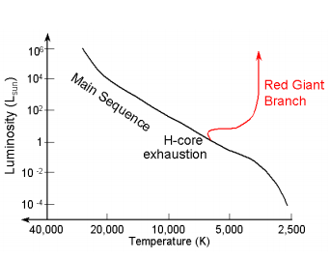At the tip of the Red Giant branch:

* Tcore reaches 100 million K
* Ignite He burning in the core in a flash

At 100 million K, a new fusion source ignite: The **Triple-alpha process.** This is the fusion of three 4He nuclei into one 12C nucleus through a nuclear reaction chain that involves the momentary formation of 8Be (see section 2.2.2.4).

Once C is formed, a secondary reaction forms O from the fusion of C and He:

12C + 4He 🡪 16O +

When this occurs, the star has a nuclear power source in its core and leaves the Giant Branch

Inside: Starts generating primary energy from He burning in the core and gets additional energy from a H burning shell surrounding the core.

Outside: gets hotter and bluer, the star shrinks in radius and gets fainter

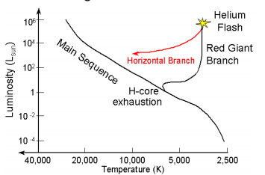The new energy source helps the star begin to regain hydrostatic and thermal equilibrium. As it does so, it moves onto the horizontal branch.

Figure

Horizontal branch

The Triple-alpha process is very inefficient at producing energy, so it can only last for about 100 Myr. While it goes on, the star steadily builds up a C-O core, but it is still too cool to ignite C fusion

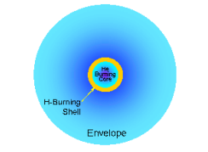

Figure

Asymptotic Giant branch

After 100 Myr, the core runs out of He for triple-Alpha fusion.

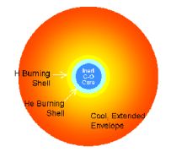

Figure

Inside: C-O collapses and heats up. He burning shell outside the C-O core, H burning shell outside the He burning shell

Outside: Star grows rapidly in radius and cools

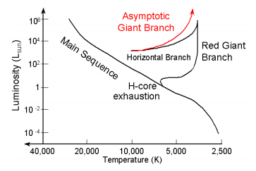

Figure

Core envelope separation:

Outer envelope gets slowly ejected (fast wind), C-O core still contracts but never reaches the C fusion temperature (600 MK), rapid process (105 years)

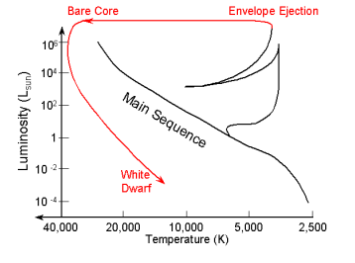Planetary nebula phase: Expanding envelope forms a nebula around a contracting C-O core.

Figure

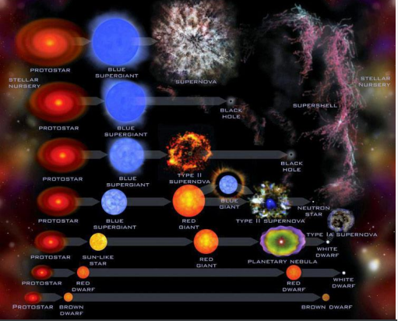

Figure

#### **2.4.3.2 High mass stars (>4 solar masses)**

Sequence:

MS star 🡪 Red supergiant 🡪 Blue supergiant 🡪 Red supergiant 🡪 White dwarf or catastrophic collapse

**Stars with 4<M<8 Mʘ**

* Burn H up through Carbon
* Blow off their envelope
* Core becomes an O-Ne-Mg white dwarf

**Stars with M>8 Mʘ**

* Burn H up through C, Ne, O and Si
* Iron core formation and burning shells
* Catastrophic collapse of iron core

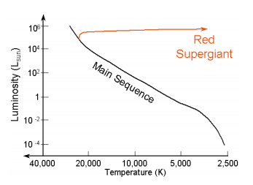Moves horizontally across the HR diagram, becoming a Red Supergiant star

Figure

Takes about 1Myr to cross the HR diagram

**After H-core exhaustion:**

* Inert He core contracts and heats up
* H burning in a shell around the contracting He core
* 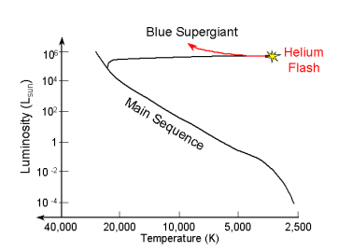Huge envelope about the size of the orbit of Jupiter 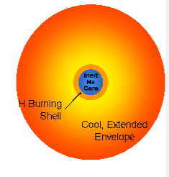

Figure

Core temperature reaches 170MK

Ignites He burning to C and O:

* Rapid phase: ~ 1Myr
* He burning in the core

Figure

* H burning in a shell
* Stars building a C-O core
* Star becomes a blue supergiant

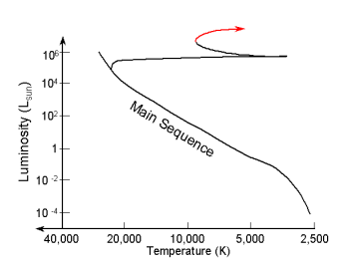**When He runs out in the core:**

Figure

* Inert C-O core collapses and heats up
* H and He burning into shells
* Becomes a Red supergiant again

**C-O core collapse until:**

* Tcore > 600 million K
* Density > 150,000 g cm-3
* Ignites Carbon burning in the core

**Nuclear reaction network: 12C + 12C fuses to:**

* 24Mg
* 20Ne + 42He
* 16O + 2 42He

Which builds up an inert O-Ne-Mg core which is very inefficient because:

* Makes many neutrinos
* Lasts only ~ 1000 years before C runs out

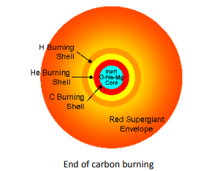

Figure

**Stars with 4 < M < 8Mʘ**

After 1000 years:

* Inert O-Ne-Mg core contracts and heats up
* C, He and H burning shells
* Thermal pulses destabilize the envelope leading to
  + Eject the envelope in a massive stellar wind
  + Leave O-Ne-Mg white dwarf core behind

#### **2.4.3.3 High mass stars (> 8 solar masses)**

**At the onset of Carbon burning:**

* Evolution is so fast that the envelope can no longer respond
* Should see little outward sign of the inward turmoil to come

Exception: strong stellar winds can erode the envelope, changing the outward appearance of the star

**Neon burning**

O-Ne-Mg core contracts and heats up until

* Tcore ~ 1.5 Billion K
* Density ~ 107 g cm-3

Ignite Neon burning:

* Reaction network makes O, Mg, and others
* Huge neutrino losses: > L*
* Builds a heavy O-Mg core

Lasts for a few years before Ne runs out

**Oxygen burning**

Ne runs out, core contracts until

* Tcore ~ 2.1 Billion K
* Density ~ few x 107g cm-3

Ignite Oxygen burning:

* Reaction network makes Si, S, P, and others
* Huge neutrino losses: > 100,000 L*
* Builds a heavy Si core

Lasts for around 1 year before O runs out

**Silicon burning**

O runs out, core contracts and heats up until:

* Tcore­ ~ 3.5 Billion K
* Density ~ 108 g cm-3

Ignite Silicon burning:

* Si melts into a sea of He, protons, and neutrons
* Fuses with rest into Ni and Fe
* Builds a heavy Ni/Fe core

Lasts for about 1 day

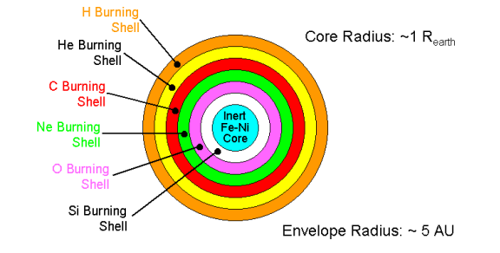

Figure

### **2.4.4 Pulsating variable stars**

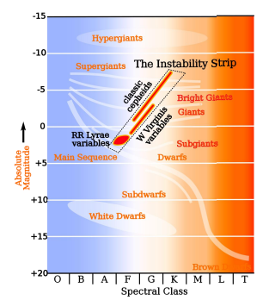

Figure

Along the instability strip:

* RR Lyrae stars
* Cepheid stars

Significant/observable contraction-expansion of the stellar radius

Table

|  |  |  |
| --- | --- | --- |
| Property | Cepheid | RR Lyrae |
| MV | -0.5, -0.6 | 0.5, 1 |
| Spectral type | F, G, K | A, F |
| Pulsation period | 1-50 days | 1.5-24 hours |
| Mass | 3-18 Mʘ | 0.5-0.7 Mʘ |
| Evolutionary stage | Supergiant | Horizontal branch |
| Metallicity | High | Low |

## **Stellar remnants**

### **White dwarfs**

Degenerate pressure or degeneracy pressure comes from the Pauli exclusion principle (PEP):

* No electrons can occupy the same state in bound orbits
* No free electrons, the closer they are to each other, the greater the momentum difference must be from:

$∆x∆p≥\frac{ℏ}{2}$ (Heisenberg uncertainty principle)

* If particles are close together, they have a higher momentum and thus exert higher pressure than predicted by the ideal gas law
* Number of quantum states available to free electrons in 6-dimensional phase-space (position and velocity) is:
$$dN=\frac{2}{ℏ^{3 }} dx dy dz dp_{x}dp_{y}dp_{z}$$

* As the core of the star is compressed by the weight of the material above it (gravitational force), all the lowest momentum states are filled, and electrons are forced to occupy higher momentum states
* Higher momentum states 🡪 momenta significantly higher than electrons would normally have dues to thermal energy alone (ideal gas law)
* Electrons will exert an enhanced pressure due to enhanced momentum 🡪 degeneracy pressure
* Stars with a progenitor of mass less than 4Mʘ end their lives as white dwarfs
* Mass loss caused by He flash reduces the mass of the remnant (< 1.4Mʘ)
* For white dwarfs, and at the time of the He-flash, the collapse is stopped by degeneracy pressure: degenerate electrons support the star in a new hydrostatic equilibrium
* End product: consists of a core of some He, but primarily Carbon and Oxygen surrounded by a He envelope

Two components of matter exist:

* Degenerate electrons: supplying the necessary enhanced pressure to reach a new hydrostatic equilibrium. A high thermal conductivity leads to the conduction being the most efficient method of energy transport.
* Ions: Supplying the mass and thermal energy

Matter inside the White Dwarf is fully ionised, even once the remnant has cooled completely due to compression/degeneracy electrons

The source of ionisation is the extreme pressure, not the temperature

For Wd, M $M α\frac{1}{R^{3}}, so R α\frac{1}{M^{\frac{1}{3}}}$

The more massive the WD is, the smaller radius it has.

Typically, mass is between 0.5 and 1 solar mass, radius of 1/100 solar radius, a surface temperature of 104K and a luminosity of 1/1000 solar luminosity.

The evolution of a WD is determined by the time needed to radiate away its remaining thermal energy. Trad about 1011 years

The end result is a black dwarf – an object that has no available energy and is gravitationally self-bound or a type 1a supernova

Black dwarfs are cold and have a dark mass

The universe is not old enough to contain any black dwarfs yet.

There does exist a limit to the mass which can be supported by electron degeneracy pressure, which is known as the Chandrasekhar limit, it is estimated to be 1.4 solar masses. For the neutron star, this limit is known as the Tolman-Oppenheimer-Volkoff limit which is between 1.5 and 3 solar masses

Thermal pressure: PH = ne kBT ~ neme vth2 with vth = (kBTme)1/2

Degeneracy pressure: $Δp \sim \frac{ℏ}{Δx}\sim ℏ{ n}_{e}^{1/3 } with Δx \sim ν^{-1/3}\sim n_{e}^{-1/3}$

$$Δν \sim \frac{Δp}{m_{e}}\sim \frac{ℏn_{e}^{\frac{1}{3}}}{m_{e}}$$

$$p_{deg }\sim n_{e}m_{e}{\left(Δν\right)}^{2}$$

$$p_{deg}\sim ℏ^{2}\frac{n_{e}^{\frac{5}{3}}}{m_{e}}$$

Degenerate electrons when $p_{deg }>p_{th}$

Radius WD

Pressure at the centre:

* Hydrostatic equilibrium: $p_{c} \sim \frac{GΠ^{2}}{R^{4}}$
* Degeneracy pressure: $p_{e} \sim ℏ^{2}\frac{n_{e}^{\frac{5}{3}}}{m_{e}} \sim \frac{ℏ^{2}}{m_{e}}\frac{ρ^{\frac{5}{3}}}{m_{p}^{\frac{5}{3}}} \sim \frac{ℏ^{2}}{n_{p}^{\frac{5}{3}}m_{e}}\frac{Π^{\frac{5}{3}}}{R^{5}}$

$$\frac{GΠ^{2}}{R^{4}}=\frac{ℏ^{2}}{m_{p}^{5/3}m_{e}}*\frac{Π^{5/3}}{R^{5}}$$

$$R \sim \frac{ℏ^{2}}{Gm_{e}m_{p}^{2}} {\left(\frac{Π}{m_{p}}\right)}^{-\frac{1}{3}}$$

### **Supernovae**

* 1054 AD: “Guest star” in taurus
  + Observed by Chinese astronomers (late song dynasty)
  + Visible in daylight for 23 days
  + Visible at night for ~ 6 months
  + Left behind the crab nebula
* 1572: Tycho Brahe’s Supernova
* 1604: Johannes Kepler’s Supernova
  + Important supernovae that were influential at the beginning of modern astronomy
* 8000 – 6000BC: Vela supernova
  + Observed by the Sumerians; appears in legends about the god Ea

**Supernova 1987a**

Nearest naked-eye visible supernova seen since 1604. The Explosion occurred on February 23rd, 1987:

* 15 Msun Blue supergiant star named SK-69o202 exploded un the Large Magellanic Cloud 9a satellite galaxy of our milky way galaxy located some 50,000 pc away).
* Particle experiments on Earth recorded a pulse of neutrinos arriving just before the burs of light from shock breakout
* Astronomers have continued to follow its developments over the last 15 years

SN1987a has provided us with a great wealth of information about supernova physics, and has helped us to confirm the basic predictions of the core-bounce picture largely experimentally

* Type Ia: no H absorption lines and no He absorption lines
* Type Ib: no H absorption lines but strong He absorption lines
* Type II: H absorption lines

### **Neutron stars/pulsars**

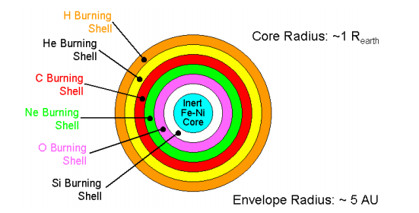

Figure

**Iron core collapse**

The iron core grows until it has accumulated a mass of around 1.2-1.4 Msun which it then collapses and begins to heat up. Core temperatures reach T>10 Billion K and density reaches ~ 1010 g cm-3. Two important energy consuming processes kick in at these temperatures:

* **Photodisintegration:**
  + High energy photons hit the heavy nuclei, which disintegrate into He, protons, and neutrons.
  + This effectively “reverses” the previous fusion, draining energy (in the form of high energy photons) out of the system
* **Neutronization:**
  + Free protons and electrons fuse into neutron and neutrinos
  + A neutron has more mass than a proton + electron so this takes energy
  + The neutrinos escape, carrying even more energy away from the star

**Catastrophic collapse**

* At the end of Iron core collapse, the core properties are:
  + Radius ~ 6000km (~Rearth)
  + Density ~ 108 g cm-3
* A second later the properties are:
  + Radius ~ 50km
  + Density ~ 1014 g cm-3
  + Collapse speed 0.25 c

The core stars left after a type II supernova explosion are called neutron stars

* We need an appropriate equation of state for matter of extreme density (degenerate pressure) as strong interactions are becoming important (reduced distance between atoms)
* Therefore, general relativity plays a role

However, we can say:

1. Primary pressure support comes from neutron degeneracy (PEP)
2. Most of the material is neutron degeneracy which stars at the core (but not fully degenerate at outer edges)

The collapse of the core can be stopped by neutron degeneracy pressure. It then becomes a neutron star:

$$P_{e} α\frac{n_{e}^{\frac{5}{3}}}{m_{e}} then P_{n }α\frac{n_{n}^{\frac{5}{3}}}{m_{n}}$$

A sphere supported by neutron degenerate pressure will have a radius of:

$$R_{NS}\sim \frac{ℏ^{2}}{Gm_{n}m_{p}^{2}} {\left(\frac{M_{NS}}{m_{p}}\right)}^{-\frac{1}{3}}$$

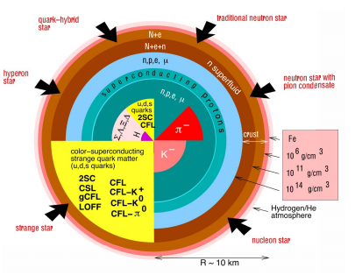

Figure

* 0-3 km: Quark -gluon
* 3-9 km: Superfluid, neutron-Fermi liquid, few e-
* 9-9.5 km: neutrons, nuclei
* 9.5-10 km: Ion-electron (not fully neutron degenerate, crystalline structure (crust))

**Average properties**

* Density: 1014- 1015 kg m-3
* Mass: 0.5 - 2.5 Mʘ
* Radius: 7 – 20 km
* Magnetic field: 106 – 108 T

Neutron stars have a high magnetic field strength, and their rotation speed increases as the star shrinks (period of rotation shortens).

**Pulsars**

Pulsars are rapidly rotating neutron stars that are highly magnetized

The rotation speed can reach 0.1c and they have magnetic field strengths of 106 T

* 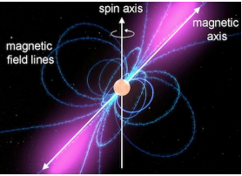EM radiation detected from pulsars is often in the form of radio waves but can extend all the way to gamma rays.

Figure

Pulsars are excellent time keeps due to their periodicity being easy to measure. For a rotation speed of 0.1c, their period is 2x10-3 s

Their first observation was by Jocelyn Bell and Anthony Hewish in 1967.

### **Black holes**

Stars with an initial mass greater than 18Mʘ will have a stellar remnant above the Tolman-Oppenheimer-Volkoff limit therefore they will end up as black holes

(More in cosmology chapter)

# **Chapter 3 – Galaxies**

## **3.1 The Milky Way**

There are three components:

* Disk
* Bulge
* Halo

Observational difficulties:

* 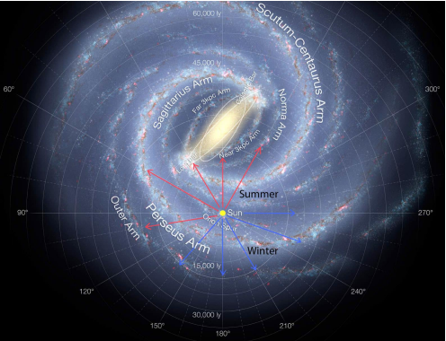The sun being inside the Milky way galaxy makes it difficult to map its structure because of the absorption of dust in the interstellar medium.

Figure : The Milky Way galaxy

* Radio waves can penetrate throughout the Milky Way’s disk

### **3.1.1 The disk**

The 21cm emission line, arising from the neutral H as the spin of e- and protons (hyperfine structure) flips is used to map the distribution of the material in the Milky Way’s disk

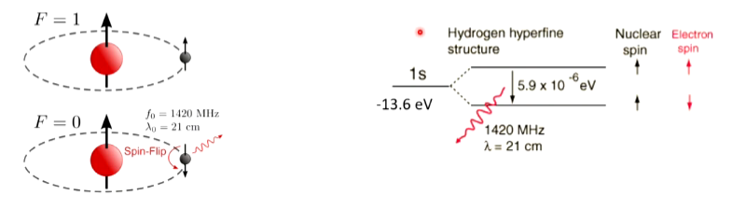

Tracers of spiral structures (arms/spiral arms)

1. HI (neutral hydrogen)
2. Young stars
3. Star forming regions
4. Galactic clusters
5. Absorbing dust

* The most luminous components: 19x109 solar luminosity compared to bulge (2x109 solar luminosity), and halo (2x109 solar luminosity)
* Population 1 of stars is young, metal-rich population (Z > 0.01)
* Thin disk: scale height of 0.3 kpc, mostly population 1, including formation region
* Thick disk: scale height of 1 kpc, older stars

### **3.1.2 The halo**

* Globular clusters trace out the halo population
* Population 2 of stars is old, metal-poor population (Z < 0.001) distributed in a sphere and large velocities perpendicular to the galactic disk

### **3.1.3 The Bulge**

* Located in the central 3 kpc region
* Star population still considered controversial: (main consensus) mostly old, metal-rich stars
* The nucleus lies at the centre of the Milky Way galaxy (maybe a black hole), typically 4x106 solar masses and a characteristic size of 13 AU; observations are made in the Infrared range.

The sun lies at 8 kpc from the galactic centre. The total luminosity is about 23x109 solar luminosity

|  |  |  |  |
| --- | --- | --- | --- |
| Component | Diameter (kpc) | Mass (Mʘ) | Constituents |
| Disk | 25 | 6x1010 | Population 1 stars, galactic clusters, star forming regions, dust, and gas |
| Halo | 35 | 2x109 | Population 2 stars, globular clusters |
| Bulge | 5 | 1010 | Stars, gas, dust, old stars with high metallicity |

### **3.1.4 The mass of the Milky Way**

We can measure the mass of the Milky Way inside a solar radius (sphere centred on the galactic centre and of the radius of the distance between the galactic centre and the Sun). Consider νʘ the velocity of the Sun around the galactic centre and R the radius of the sphere, M the mass at the galactic centre:

$\frac{GMm}{R^{2}}=\frac{mν_{⊙}^{2}}{R}$

$$M=\frac{Rν_{⊙}^{2}}{G}$$

Rotational velocity for the Sun: 220 km s-1

Velocities measured from globular clusters at the same distance from the galactic centre

Estimated mass: 1011 solar masses

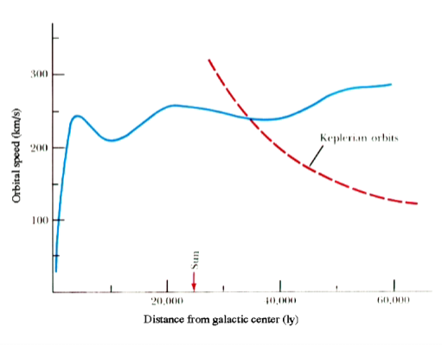From the rotational curve, the speed is almost constant with the distance. Therefore, the mass must increase with R and not R1/2 as in the Keplerian case

Figure

Where does this excess of mass come from?

* Dark matter in the outskirts of the galaxy’s disk
* Neutrino: is there a mass?

## 3.2 **The Hubble classification**

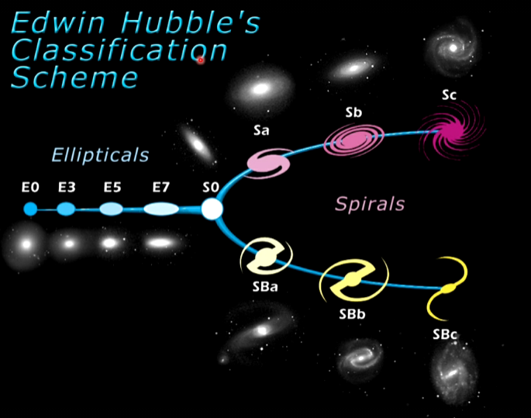

Figure : Galactic classification scheme

* Elliptical galaxies: no structure, ellipsoidal in shape; no gas or star formation; range and shape from sphere to the major axis being more than twice the minor axis
* Spiral galaxies: Spiral structure, gas, dust (see description of Milky Way)
* Irregular galaxies: no organised structure, lots of gas and young stars

For elliptical, E0 🡪 E10 from spherical to large aspect ratio

For spiral, Sa – Sb – Sc from large bulge to small bulge

Colour and stellar population:

The Hubble classification is a progression to increasing blue colours, i.e., increasing importance of population 1 (young stars)

Table

|  |  |  |  |
| --- | --- | --- | --- |
|  | Spiral | Elliptical | Irregular |
| Mass (Mʘ) | 109 - 4x1011 | 105 - 1013 | 108 - 3x1010 |
| Luminosity (Lʘ) | 108 - 2x1011 | 3x105 - 1011 | 107- 109 |
| Diameter (kpc) | 5-250 | 1-200 | 1- 10 |
| Population | 1 in disk, 2-old 1 in nucleus | 2 and old-1 | 1 |
| % of observed galaxies | 77% | 20% | 3% |

### **3.2.1 Hubble’s law**

In 1928, Slipher measured the velocities of galaxies and found that almost all were receding from the Milky Way (redshifted). Hubble measured the distance to many of these galaxies using the Cepheid period-luminosity relationship. He found that what is now known as the Hubble law:

$ν=Hd$ Where H is the Hubble constant, an estimate of the age of the universe

The current value of H (sometimes denoted as H0) = 71 km s-1 Mpc-1

The inverse gives an estimate of the age of the universe

Hubble’s law is direct evidence of an expanding universe. Implications of Hubble’s law:

* Galaxies were closer together in the past, so interactions and mergers were more frequent
* The density increases in the past
* A finite time ago, all of the mass was in one place (a singularity), so the idea of a big bang

Uniform expansion (redshifted) does not require the Milky Way to be in a special place in the universe. Any observed in a uniformly expanding universe will see the galaxies receding according to Hubble’s law

The Tully-Fisher relationship for spiral galaxies

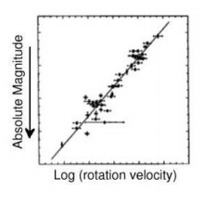This is an observational relationship between the rotational speed and the absolute magnitude of spiral galaxies:

Figure

The relationship for two clusters of galaxies, one further than the other, allows to estimate the relative distance between the two clusters.

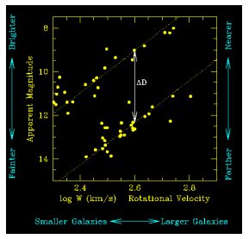

Figure

## **3.3 Galaxy formation and mergers**

What are the main scenarios of galaxy of galaxy formation?  
 How to make a structure as large as a galaxy?

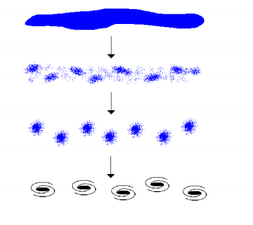

Top-down scenario

Starting from a large sheet of material, fragmenting into small clumps of matter, leading to the formation of galaxies and clusters of galaxies.

Figure

Bottom-up scenario

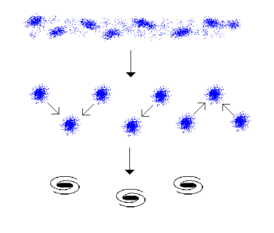Starting from a small, dwarf-galaxy size matter, merging into galaxies and clusters of galaxies

Figure

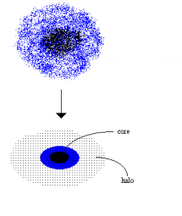Protogalaxy scenario

Hybrid of top-down/bottom-up scenario, where small dense clumps of matter collapse first, and large ones form slowly and fragment. Gravitational collapse leads to the formation of a proto-galaxy

Figure

Elliptical vs Spiral galaxies

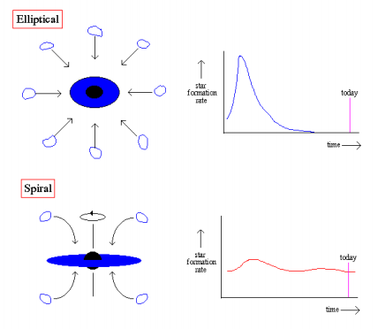The formation of galaxies is linked to the density enhancement occurring at the time of recombination.

The most important parameter is the star formation rate

Figure

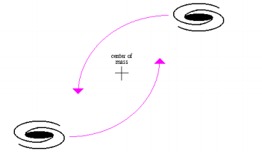

Minor merger: One large and one small galaxy interacting

Major merger: Two galaxies of similar size interacting

Similar to inelastic collision: some of the energy is transferred to stars and gas within the galaxies

Figure

Merging process modifies the mass evolution and morphology of galaxies

Figure

Active galaxies: galaxies producing a large amount of non-stellar emission, arising from energetic and violent processes. A large part of the light is concentrated in a central region called active galactic nucleus (AGN)

Types of active galaxies:

* Seyfert galaxies: spiral galaxies with variable, luminous nucleus
* Quasars: quasi-stellar radio source, AGN with large luminosity (1014solar luminosity)
* Radio galaxies: galaxies with strong radio emission.

The Eddington limit

Energy of photons: $∆E_{phot}≈η mc^{2}$ Where η is efficiency

For an AGN: η = 0.1

Luminosity: $L=\frac{∆E_{phot}}{∆t}=η\dot{Π}c^{2}$ where $Π$ = rate of change of mass dm/dt

If L = 1000 Lʘ Then, = 10-9

Flux:

For photon: $F_{P}=\frac{F}{c}=\frac{L}{4π{cr}^{2}} Momentum flux$

For electrons: transfer of momentum: 🡨force radiating away

Where $σ_{e}$ = Thomson cross-section

Gravity: electrons and protons

Fg = = Mass of black hole

Eddington limit: When Frad and F­g are balanced

🡪

## **3.4 Clusters and local environment**

### **3.4.1 Different types of star clusters**

Table

|  |  |  |
| --- | --- | --- |
|  | Galactic star clusters | Globular star clusters |
| # of stars | 100-1000 | 105 – 106 |
| Location | In the disk and in spiral arms  3 stars per pc3 | In the halo  > 103 stars per pc3 |
| Appearance | Open, loose, aggregates | Spherical, core like |
| Spectra | Strong metallic lines | Weak magnetic lines |
| Example | Pleiades | M13 |
| Star population | Population 1 | Population 2 |

# **Chapter 4 – Introduction to cosmology**

## **4.1 The Expanding universe**

### **4.1.1 Overview**

1920 – Discovery of extended galaxies

1924 – Hubble expansion

1965 – Detection of the microwave background

1991 – Fluctuations in the microwave background

1. Lord Kelvin suggested that dust in the Universe could absorb light, making the flux fall faster than 1/r2. However, eventually the dust would be warmed and come into equilibrium re-radiating as much energy as it absorbs, although at longer wavelengths.
2. Expansion of the universe can redshift radiation from distant stars. However, this still leaves the flux integrated over all wavelengths as infinite.
3. The universe is not infinite in either space or time. This is the modern view in the Big Bang model. Moreover, stars themselves only have a finite lifetime, and as they burn H, there cannot be infinite generation of stars.

### **4.1.2 The Olber’s paradox**

“The night sky is dark at visible wavelengths, instead of being uniformly bright with starlight.”

The derivation of the flux with the assumption “it’s the same the Sun’s” Implies that the entire night sky should be as bright as the Sun, with the extra assumptions that the Universe is infinite, and the full sky is paved with stars

Nowadays, using those assumptions we know that the brightness of the night sky is off by a factor of 100 trillion.

### **4.1.3 The cosmological principle**

Definition:

The universe is isotropic and homogeneous on large scales

Isotropic means there are no preferred directions in the universe, Homogeneous means that there are no preferred locations in the universe. If the universe is isotropic for all observers, then it is necessarily homogeneous

Distribution of galaxies as a function of redshift

The universe obeys the cosmological principle at scales larger than 333 Mpc.

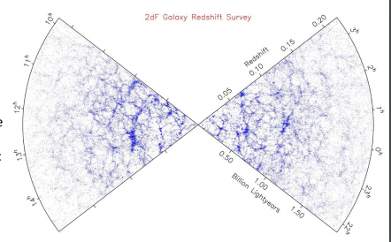

The perfect cosmological principle: The universe is isotropic and homogeneous on larger scales in space AND time

This assumption has led to the Steady State Theory, which is now rejected in favour of an expanding universe, due to it requiring a continuous supply of matter.

The Hubble’s law assumes that the universe is isotropic and homogeneous

$\underline{ν}= H_{0}\underline{r}$

Where H0 is the Hubble constant at present time. The Hubble’s law can also be written by introducing the Doppler shift, z:

$z=\frac{H_{0}}{c}r$

The redshift can be measured by: $z=\frac{λ_{obs} - λ_{emit}}{λ_{emit}}$

* The Hubble’s law is based on the cosmological principle (homogeneous and isotropic)
* In the mid-1920s Edwin Hubble measured the distance and redshifts of sets of nearby galaxies, and found them to follow this law
* Expansion: do not think of galaxies as expanding apart, but as the space is expanding, dragging galaxies with it. Thus, there is no centre to the expansion (refer to balloon model)

### **4.1.4 Modelling the expansion**

* Derivation of the Friedman equations from Newtonian mechanics
* Definition of the Hubble constant, the critical density, the density parameter

Considering that the universe is described by a sphere of radius, r, and a homogeneous density ρ(t), The Newton’s second law is

$m\ddot{r}= -\frac{GMm}{r^{2}}= -\frac{4πGρ(t)r^{3}}{3r^{2}}$

Where m is the mass of an element within the sphere, M is the mass of the universe, and G is the gravitational constant

To integrate, we use the conservation of mass within the expanding sphere, assuming that the mass at present time is known:

$$ρ\left(t\right)r^{3}\left(t\right)= ρ_{0}r_{0}^{3}$$

In an expanding universe, we can introduce the expansion factor a(t), defined as r(t) = a(t)R0 where R0 is the initial radius.

Integrating the Newton’s second law gives:

$${\left(\frac{\dot{a}\left(t\right)}{a\left(t\right)}\right)}^{2}=\frac{8πG}{3}ρ\left(t\right)-\frac{Kc^{2}}{a^{2}(t)}$$

Where K is a constant

This is the first Friedmann equation

#### 4.1.4.1 Newtonian approach

F = ma

$$-\frac{GΠm}{r^{2}}=m\ddot{r}$$

$$\ddot{r}=-\frac{GΠ}{r^{2}}$$

Assumption: Sphere: $Π=\frac{4π}{3}ρ\left(t\right)r^{3}(t)$

$$\ddot{r}=-\frac{4πG }{3}\frac{ρ\left(t\right)r^{3}(t)}{r^{2}}$$

Assumption: Mass is conserved:

$\frac{4π}{3}ρ\left(t\right)r^{3}\left(t\right)=\frac{4π}{3}ρ_{0}R_{0}^{3}$

$$\ddot{r}= -\frac{4πG}{3}\frac{ρ_{0}R_{0}^{3}}{r^{2}}$$

Expansion factor, a(t)

$$r\left(r\right)=a\left(t\right)R{}_{0}$$

At the present time, t0

Integrate

$$\frac{1}{2}a^{2}=\frac{4πG}{3}ρ_{0}\frac{1}{a}+C$$

$\frac{1}{2}a^{2}=\frac{4πG}{3} ρ\left(t\right)\frac{a^{3}\left(t\right)}{a}+C$

$$\frac{1}{2}a^{2}=\frac{4πG}{3} ρ\left(t\right)a^{2}\left(t\right)+C$$

$${\left(\frac{\dot{a}}{a}\right)}^{2}=\frac{8πG}{3}ρ\left(t\right)+\frac{C}{a^{2}}$$

${\left(\frac{\dot{a}}{a}\right)}^{2}=\frac{8πG}{3} ρ\left(t\right)-\frac{Kc^{2}}{a^{2}}$ 1st Friedmann equation

#### 4.1.4.2 The Hubble constant

From Hubble’s law:

$$H^{2}\left(t\right)={\left(\frac{\dot{a}}{a}\right)}^{2}$$

From the Friedmann equation,

At the present time, t0:

At a time, t: $H^{2}=\frac{8πG}{3} ρ\left(t\right)-\frac{Kc^{2}}{a^{2}(t)}$

#### 4.1.4.3 Critical density

Obtained for K = 0 (flat universe)

At a time, t: $ρ_{crit}=\frac{3H^{2}\left(t\right)}{8πG}$

At the present time, t0:

The critical density at the present time is estimated to be 10-26 kg m-3

#### 4.1.4.4 Density parameter

$Ω=\frac{ρ}{ρ_{crit }}$

This is a measure of the departure from a flat universe density

Open universe for $Ω$ < 1, K < 0 and ρ < ρcrit

Close universe for $Ω$ > 1, K > 0 and ρ > ρcrit

Flat universe for $Ω=1$, K = 0 and ρ = ρcrit

Using the Friedmann equation, we can derive a relationship between the density parameter and the Hubble constant:

$\left|Ω\left(t\right)-1\right|=\frac{\left|K\right|c^{2}}{a^{2}\left(t\right)H^{2}(t)}$

The comoving distance is $x=\frac{r}{a(t)}$ such that the separation x remains constant with the expansion

Using the definition of the redshift, we obtain:

$\frac{λ_{observed}}{λ_{emitted}}=\frac{1}{a\left(t\right)}=1+z$

As a photon observed at the present time was emitted when the universe had an expansion factor a(t), and using the convention that a (t0) = 1

The age of the universe can be obtained from Hubble time:

$$t_{H}=\frac{1}{H_{0}}$$

We will see in the next section that the Hubble time corresponds to the age of the universe in an empty universe without the cosmological constant. This is an upper limit for the age of the universe.

#### 4.1.4.5 The fluid and acceleration equations (2nd Friedmann equation)

In thermodynamic, an expanding fluid follows:

$$dE+pdV=dQ=TdS$$

Where Q is the heat, S is the entropy, pdV is the work done and

$$E=mc^{2}=ρVc^{2}=\frac{4}{3}πρr^{3}c^{3}$$

For a spherical universe:

$$E=ρVc^{2}$$

$$\frac{dE}{dt}=Vc^{2}\frac{dρ}{dt}+ρc^{2}\frac{dv}{dt}$$

$$dE=Vc^{2}\frac{dρ}{dt} +ρc^{2}dV$$

If dQ = 0 then: $dE+pdV=0$

$$Vc^{2}\frac{dρ}{dt}+ρc^{2}\frac{dV}{dt}= -p\frac{dV}{dt}$$

$$V\frac{dρ}{dt}+\left(ρ+\frac{p}{c^{2}}\right)\frac{dV}{dt}=0$$

$$V=\frac{4}{3}πr^{3}=\frac{4}{3}πR_{0}^{3}a^{3}$$

$$\frac{dV}{dt}=\frac{4}{3}πR_{0}^{3}(3\dot{a} a^{2})$$

$$a^{3}\frac{dρ}{dt}+\left(ρ+\frac{p}{c^{2}}\right)3\dot{a} a^{2}=0$$

$$\frac{dρ}{dt}+3 \dot{\frac{a}{a}} \left(ρ+\frac{p}{c^{2}}\right)=0$$

In the case of an expanding universe, there is no exchange of heat, so dQ=0 and by differentiating the previous equation, we obtain:

$$\frac{dρ}{dt}+\frac{3}{a}\frac{da}{dt}\left(ρ+\frac{p}{c^{2}}\right)=0$$

Using that V α a3

This is the fluid equation

By differentiating the 1st Friedmann eq.,

$$\frac{d}{dt}\left(\frac{{\dot{a}}^{2}}{a^{2}}\right)=\frac{8πG}{3}\frac{dρ}{dt} -Kc^{2}\frac{d}{dt}\left(\frac{1}{a^{2}}\right)$$

$$\frac{2\dot{a}\ddot{a}a^{2}-\dot{a^{2}}*2\dot{a}a}{a^{4}}=\frac{8πG}{3}\frac{dρ}{dt}-Kc^{2}\left(\frac{-2a\dot{a}}{a^{4}}\right)$$

$$\frac{2\dot{a}a\left(\ddot{a}a-{\dot{a}}^{2}\right)}{a^{4}}=\frac{8πG}{3}\frac{dρ}{dt}-2Kc^{2}\frac{\dot{a}}{a^{3}}$$

$$(/\dot{2a}) \frac{a}{a^{2}}- \dot{\frac{a^{2}}{a^{3}}=\frac{4πG}{3}\frac{1}{\dot{a}}\frac{dρ}{dt}+\frac{Kc^{2}}{a^{3}}}$$

$$\left(xa\right)\ddot{\frac{\ddot{a}}{a}-\dot{\frac{{\dot{a}}^{2}}{a^{4}}=\frac{4πG}{3}}\frac{a}{\dot{a}}}$$

$$\ddot{\frac{a}{a}}-\left[\frac{8πG}{3}ρ-\frac{Kc^{2}}{a^{2}}\right]=\frac{4πG}{3} \left(-3\left(ρ+\frac{p}{c^{2}}\right)\right)+\frac{Kc^{2}}{a^{2}}$$

$$\ddot{\frac{\ddot{a}}{a}= -\frac{4πG}{3}\left(3ρ+3\frac{p}{c^{2}}\right)+\frac{8πG}{3}ρ }$$

Leading to the acceleration equation (2nd Friedmann equation):

$$\frac{\ddot{a}}{a}= -\frac{4πG}{3} \left(ρ+\frac{3p}{c^{2}}\right)$$

In this equation there are no pressure gradients, so then pressure does not create a force that contributes to the expansion of the universe. However, the energy is altered by the work done (pdV)

Provided $p>\frac{-pc^{2}}{3}$, $\ddot{a}$ is negative and the universe is decelerating.

#### 4.1.4.6 The cosmological constant

Assuming that there is a vacuum with a positive energy density, $ε_{vac}= ρ_{vac}c^{2}$, the exchange of heat equation, (dQ = 0) gives:

$$p_{vac}= -p_{vac}c^{2}$$

From the acceleration equation, with ptot = p + pvac,

Where $Λ=8πGρ_{vac}$

The Friedmann equations with cosmological constant become

$${\left(\frac{\dot{a}\left(t\right)}{a\left(t\right)}\right)}^{2}=\frac{8πG}{3} ρ\left(t\right)-\frac{Kc^{2}}{a^{2}\left(t\right)}+\frac{Λ}{3}$$

**And**

$$\frac{\ddot{a}}{a}= -\frac{4πG}{3} \left(ρ+\frac{3p}{c^{2}}\right)+\frac{Λ}{3}$$

#### 4.1.4.7 The Robertson-Walker metric

The space-time metric describing the expansion of the universe is given by the Robertson-Walker metric:

$$ds^{2}=dτ^{2}=dt^{2}-a^{2}\left(t\right)\left[\frac{dr^{2}}{1-Kr^{2}}+r^{2}\left[dθ^{2}+\sin^{2}\left(θdφ^{2}\right) \right] \right]$$

Where a is the expansion factor, k is prescribing the curvature of the universe

K = -1 for an open universe

K = 0 for a flat universe

K = 1 for a closed universe

Trajectory of photons: null geodesic

$$ds^{2}=0$$

Using spherical symmetry ($dθ=dφ=0$)

$$dt^{2}=a^{2}\left(t\right)\frac{dr^{2}}{1-Kr^{2}}$$

$${\left(\frac{dr^{2}}{dt^{2}}\right)}^{2}=\frac{1-kr^{2}}{a^{2}}$$

This is the equation of straight lines in the radial direction.

It is important to know:

* Tensor notations, including free/dummy indices, contraction
* Covariant and contravariant components, e.g., $g_{μν} and g^{μν}$
* Christoffel symbols, Riemann tensor, Ricci tensor and scalar
* Einstein’s field equation with cosmological constant

Metric: $ds^{2}=g_{μν}dx^{μ}dx^{ν} With μ,ν=0,1,2,3$

$$dx^{0}=dt; dx^{1}=dr; dx^{2}=dθ; dx^{3}=dφ$$

Robertson-Walker metric: terms in dt2, dr2, dθ2, , no terms in dtdr, dtdθ ….

μ = ν

$$μ≠ν$$

$$g_{μν}=0 μ≠ν$$

$$g_{00}=1; g_{11}= -\frac{a^{2}}{1-kr^{2}}; g_{22}= -a^{2}r^{2}; g_{33}=-a^{2}r^{2}\sin^{2}{θ}$$

$$g_{μν = }\left(\begin{matrix}1 & 0 & 0 & 0 \\ 0 & -\frac{a^{2}}{1-kr^{2}} & 0 & 0 \\ 0 & 0 & -a^{2}r^{2} & 0 \\ 0 & 0 & 0 & -a^{2}r^{2}\sin^{2}{θ}\end{matrix}\right)\begin{matrix}dt \\ dr \\ dθ \\ dφ\end{matrix}$$

$$g^{μν }={\left(g_{μν}\right)}^{-1}$$

Inverse of a diagonal matrix is given by the inverse of the elements

$$g^{μν }=\left(\begin{matrix}1 & 0 & 0 & 0 \\ 0 & -\frac{1-kr^{2} }{a^{2}} & 0 & 0 \\ 0 & 0 & -\frac{1}{a^{2}r^{2}} & 0 \\ 0 & 0 & 0 & -\frac{1}{a^{2}r^{2}\sin^{2}{θ}}\end{matrix}\right)$$

#### 4.1.4.8 Christoffel symbols $Γ$

Second kind: $Γ_{νσ}^{μ}=\frac{1}{2}g^{μλ}\left(g_{λν, σ}+g_{λσ, ν}-g_{νσ, λ}\right)=g^{μλ}Γ_{λμσ }$

$Γ_{λμσ }$ = first kind

$g_{λν, σ}$ = first derivative of $g_{λν} w.r.t σ$

$$μ,ν ,σ=free indicies$$

$$λ=dummy index$$

$g^{μλ}*g_{λν, σ}=\sum_{λ=0}^{3}{g^{μλ}g_{λ, σ}}$

Derivative: $g_{11, 1}=\frac{d}{dr}\left(-\frac{a^{2}}{1-kr^{2}}\right)$ $with a=a\left(t\right)$

$$g{}_{11,1}= -a^{2}\frac{d}{dr}\left(\frac{1}{1-kr^{2}}\right)$$

$$g_{11,1}= -a^{2}\left(\frac{2kr}{{\left(1-kr^{2}\right)}^{2}}\right)$$

$$Γ_{00}^{0}=\frac{1}{2}g^{0λ}\left(g_{λ,0}+g_{λ0,0}-g_{00,λ}\right)$$

$$g^{0λ}g_{λ0,0}=g^{00}g_{00,0 }=0$$

$$Γ_{00}^{0}=0$$

$$Γ_{11}^{1}=\frac{1}{2}g^{1λ}\left(g_{λ1,1}+g_{λ1,1}-g_{11, λ}\right)$$

$$Γ_{11}^{1}=\frac{1}{2}g^{11}\left(g_{11,1}+g_{11,1}-g_{11,1}\right)=\frac{1}{2}g^{11}\left(g_{11,1}\right)$$

$$Γ_{11}^{1}=\frac{1}{2}\left(-\frac{\left(1-kr^{2}\right)}{a^{2}}\right)\left(-a^{2}\frac{2kr}{{\left(1-kr^{2}\right)}^{2}}\right)= \frac{kr}{1-kr^{2}}$$

$$Γ_{νσ}^{μ }=\frac{1}{2} g^{μλ}\left(g_{λν,σ}+g_{λσ,ν}-g_{νσ, λ}\right)$$

$μ=0→g^{μλ}≠0→λ=0→\left\{\begin{matrix}g_{0ν,σ} \\ g_{0σ, ν} \\ g_{νσ, 0}\end{matrix}\right\}→\left\{\begin{matrix}ν=0 \\ σ=0 \\ …\end{matrix}\right\}→Γ_{00}^{0}$

Riemann tensor: $R_{μνσ}^{α}=Γ_{μσ,ν}^{α}-Γ_{μν,σ}^{α}+Γ_{μσ}^{τ}Γ_{τν}^{α}-Γ_{μν }^{τ}Γ_{τσ}^{α}$

Where $τ$ is a dummy index

Ricci: $R_{μν}=R_{μαν}^{α}$

If $μ=ν=0$ then $R_{00}=R_{000}^{0}+R_{010}^{1}+R_{020}^{2}+R_{030}^{3}$

$$R_{000}^{0}=0; R_{010}^{1}= -\frac{\ddot{a}}{a}; R_{020}^{2}= -\ddot{\frac{a}{a}}; R_{030}^{3}= -\frac{\ddot{a}}{a}$$

So: $R_{00}= -3\frac{\ddot{a}}{a}$

If $μ=ν=1$ Then $R_{11}=R_{101}^{0}+R_{111}^{1}+R_{121}^{2}+R_{131}^{3}$

$$R_{101}^{0}=\frac{\ddot{a}a}{1-kr^{2}}; R_{111}^{1}= 0; R_{121}^{2}=\frac{{\dot{a}}^{2}+k}{1-kr^{2}}; R_{131}^{3}=\frac{{\dot{a}}^{2}+k }{1-kr^{2}}$$

So $R_{11}=\frac{\ddot{a}a+2\left({\dot{a}}^{2}+k\right)}{1-kr^{2}}$

If $μ=ν=2$ Then $R_{22}=R_{202}^{0}+R_{212}^{1}+R_{222}^{2}+R_{232}^{3}$

$$R_{22}= \ddot{a}ar^{2}+r^{2}\left({\dot{a}}^{2}+k\right)+0+r^{2}\left({\dot{a}}^{2}+k\right)$$

$$R_{22}=\left(\ddot{a}\dot{a}+2{\dot{a}}^{2}+2k\right)r^{2}$$

If $μ=ν=3$ Then $R_{33}=R_{030}^{0}+R_{131}^{1}+R_{232}^{2}+R_{333}^{3}$

$$R_{33}=r^{2}\ddot{a}a\sin^{2}{θ+ }r^{2}\sin^{2}{θ\left({\dot{a}}^{2}\right)+r^{2}\sin^{2}{θ\left({\dot{a}}^{2}+k\right)+0} }$$

$$R_{33}=r^{2}\sin^{2}{θ\left(\ddot{a}\dot{a}+2{\dot{a}}^{2}+2k\right)}$$

#### 4.1.4.9 Christoffel symbols of second kind

$$Γ_{11}^{0}=\frac{\dot{a}a}{1-kr^{2}}$$

$$Γ_{22}^{0}= \dot{a}ar^{2}$$

$$Γ_{33}^{0}=\dot{a}ar^{2}\sin^{2}{θ}$$

$$Γ_{10}^{1}=Γ_{01}^{1}=\frac{\dot{a}}{a}$$

$$Γ_{11}^{1}=\frac{kr}{1-kr^{2}}$$

$$Γ_{22}^{1}= -r\left(1-kr^{2}\right)$$

$$Γ_{33}^{1}= -r\left(1-kr^{2}\right)\sin^{2}{θ}$$

$$Γ_{20}^{2}=Γ_{02}^{2}=\frac{\dot{a}}{a}$$

$$Γ_{21}^{2}=Γ_{12}^{2}=\frac{1}{r}$$

$$Γ_{33}^{2}= -cosθsinθ$$

$$Γ_{30}^{3}= Γ_{03}^{3}=\frac{\dot{a}}{a}$$

$$Γ_{31}^{3}= Γ_{13}^{3}=\frac{1}{r}Γ_{32}^{3}=Γ_{23}^{3}=\frac{1}{tanθ}$$

#### 4.1.4.10 Components of the Riemann tensor

$$R_{101}^{0}=\frac{\ddot{a}a}{1-kr^{2}}$$

$$R_{202}^{0}= \ddot{a}ar^{2}$$

$$R_{303}^{0}=r^{2}\ddot{a}{a sin}^{2}θ$$

$$R_{010}^{1}= -\frac{\ddot{a}}{a}$$

$$R_{212}^{1}=r^{2}\left({\dot{a}}^{2}+k\right)$$

$$R_{313}^{1}=r^{2}\sin^{2}{θ\left({\dot{a}}^{2}+k\right)}$$

$$R_{020}^{2}= -\frac{\ddot{a}}{a}$$

$$R_{121}^{2}=\frac{{\dot{a}}^{2}+k}{1-kr^{2}}$$

$$R_{323}^{2}=r^{2}\sin^{2}{θ\left({\dot{a}}^{2}+k\right)}$$

$$R_{030}^{3}= -\frac{\ddot{a}}{a}$$

$$R_{131}^{3}=\frac{{\dot{a}}^{2}+k}{1-kr^{2}}$$

$$R_{232}^{3}=r^{2}\left({\dot{a}}^{2}+k\right)$$

#### 4.1.4.11 Ricci scalar

$$R=g^{μν}R_{μν}$$

$g^{μν}≠0$ when $μ=ν$

$$R=g^{00}R_{00}+g^{11}R_{11}+g^{22}R_{22}+g^{33}R_{33}$$

$$R=-3\frac{\ddot{a}}{a}-\frac{1-kr^{2}}{a^{2}}\left(\frac{\ddot{a}a+2\dot{a^{2}}+2k}{1-kr^{2}}\right)-\frac{1}{a^{2}r^{2}}\left(\ddot{a}a+2\dot{a^{2}}+2k\right)r^{2}-\frac{1}{a^{2}r^{2}\sin^{2}{θ} }r^{2}\sin^{2}{θ(\ddot{a}a}+2{\dot{a}}^{2}+2k)$$

$$R= -3\frac{\ddot{a}}{a}-3\frac{\ddot{a}}{a}-6\frac{{\dot{a}}^{2}}{a^{2}}-6\frac{k}{a^{2}}$$

$$R=-6\frac{\ddot{a}}{a}-6\frac{{\dot{a}}^{2}}{a^{2}}-6\frac{k}{a^{2}}$$

#### 4.1.4.12 Einstein’s field equation

$$G_{μν}-Λg_{μν}=8πGT_{μν}$$

$$Λ=0;$$

$G_{μν}=R_{μν}-\frac{1}{2}g_{μν}R$ Einstein tensor

$T_{μν}$: Stress-energy tensor, momentum-energy tensor

T00 = = Kinetic energy

T11 =

T22 = pr2

T33 = a2pr2sin2()

Then

(1st equation)

With :

If

(x 1-kr2)

1st Friedmann eq.

$$-2\ddot{a}a-{\dot{a}}^{2}-k=8πGPa^{2}$$

$-2\frac{\ddot{a}}{a}-\frac{\left({\dot{a}}^{2}+k\right)}{a^{2}}=8πGp$

$\frac{\ddot{a}}{a}=-\frac{4πG }{3}\left(ρ+3p\right)$ $\frac{\ddot{a}}{a}=\frac{8πG}{3}ρ$

## **4.2 Models of Universe(s)**

### **4.2.1 Empty universes**

#### **4.2.1.1 Empty Universe**

In the Friedmann equation, we consider that the universe is empty ($ρ$ =0) and there is no cosmological constant; only the curvature is considered

$${\left(\frac{\dot{a}}{a}\right)}^{2}= -\frac{Kc^{2}}{a^{2}} Curvature$$

$${\dot{a}}^{2}=-Kc^{2}$$

There exists a standard solution for K=0, thus $\dot{a}$ =0. So, a flat static universe is a possible solution of the Friedmann equation.

If K>0 then ${\dot{a}}^{2}=-c^{2} Leads to a complex solution$

In more general terms, a solution is obtained when K<0

$$\dot{a}=\sqrt{IKI} c$$

Integrating this equation, we obtain:

$$a\left(t\right)=\frac{t}{t_{0}}$$

Proof:

$$\dot{a}=\sqrt{IKI} c$$

(Integrate) $a=\sqrt{IKI} ct+C$

At t=0

At t=t0

Age of the universe

#### **4.2.1.2 de Sitter model**

The de sitter model consider a flat, empty universe, only the cosmological constant stay on the right-hand side of the Friedmann equation

$${\left(\frac{\dot{a}}{a}\right)}^{2}=\frac{Λ}{3}$$

This equation gives that

$$a\left(t\right)=Ce^{\sqrt{\frac{Λ}{3}t} }=e^{\sqrt{\frac{Λ}{3}} \left(t-t_{0}\right)}$$

Proof:

At t=t0

de Sitter model is infinitely old

### **4.2.2 Friedmann models**

#### **4.2.2.1 Components of energy density**

We now consider the different content of the matter in the universe:

* Matter
* Radiation and vacuum, such as

$$ρ_{tot}= ρ_{m}+ρ_{r}+ρ_{vac}$$

The Friedmann equation can then be re-written:

${\left(\frac{\dot{a}}{a}\right)}^{2}=-\frac{Kc^{2}}{a^{2}}+\frac{8πG}{3}ρ_{vac,0}+\frac{8πG}{3} ρ_{m,0 }{\left(\frac{a_{0}}{a}\right)}^{3}+\frac{8πG}{3}ρ_{r,0}{\left(\frac{a_{0}}{a}\right)}^{4}$

Where the index 0 means at the present time

The matter term is obtained from the conservation of mass within a spherical volume

$$ρ_{m}= ρ_{m,0}{\left(\frac{a_{0}}{a}\right)}^{3}→mass at t=mass at t_{0}$$

$$ρ_{m}\frac{4π}{3} R_{0}^{3}a^{3}= ρ_{m,0}\frac{4}{3}π R_{0}^{3} a_{0}^{3}$$

The radiation term is obtained from the Stefan-Boltzmann law for radiation (see chapter 2)

$$ρ_{rad}=\frac{1}{3}aT^{4} With a being a constant$$

$$ρ_{r}= ρ_{r,0}{\left(\frac{a_{0}}{a}\right)}^{4}$$

From the Friedmann equation, we can study the relative effects of the different energy density terms on the evolution of the universe.

#### **4.2.2.2 Matter-dominated universe**

From the Friedmann equation and using the conservation of mass:

$$a\left(t\right)={\left(\frac{t}{t_{0}}\right)}^{\frac{2}{3}}$$

Where

At t=t0

Integrating:

At t=0

Define t0 =

Proper distance:

$$dp\left(t_{0}\right)=c\int_{t_{e}}^{t_{0}}{\frac{dt}{a\left(t\right)}}$$

$$t_{0}:Light received at the present time$$

$$t_{e}:Light emitted by the object$$

$$dp\left(t_{0}\right)=c\int_{t_{e}}^{t_{0}}{{\left(\frac{t_{0}}{t}\right)}^{\frac{2}{3}}dt=ct_{0}^{\frac{2}{3}}\int_{t_{e}}^{t_{0}}{ }t^{-\frac{2}{3}} dt=ct_{0}^{\frac{2}{3}}{\left[3t^{\frac{1}{3}}\right]}_{t_{e}}^{t_{0}}}$$

$$dp\left(t_{0}\right) =3ct_{0}^{\frac{2}{3}}\left(t_{0}^{\frac{1}{3}}-t_{e}\right)= 3ct_{0}\left(1-{\left(\frac{t_{e}}{t_{0}}\right)}^{\frac{1}{3}}\right)$$

#### **4.2.2.3 Radiation-dominated Universe**

From the Friedmann equation and the Stefan-Boltzmann law

$$ρ_{r}=ρ_{r,0}{\left(\frac{a_{0}}{a}\right)}^{4}$$

$a\left(t\right)={\left(\frac{t}{t_{0}}\right)}^{\frac{1}{2}}$ $where t_{0}=\frac{1}{2H_{0}}$

Density of energy: $ε=n\frac{ℏc}{ lambda }$ $n α a^{-3} →ε α a^{-4}$

Where n = number density

Friedmann equation: ${\left(\frac{\dot{a}}{a}\right)}^{2}=\frac{8πG}{3} ρ_{r,0} {\left(\frac{a_{0}}{a}\right)}^{4}$

$${\dot{a}}^{2}a^{2}=\frac{8πG}{3}ρ_{r,0 }a_{0}^{4}$$

$$\dot{a}a={\left(\frac{8πG}{3}ρ_{r,0}a_{0}^{4}\right)}^{\frac{1}{2}}$$

Integrate $\frac{1}{2}a^{2}={\left(\frac{8πG}{3}ρ_{r,0}a_{0}^{4}\right)}^{\frac{1}{2}}+C$

At t=0 $a\left(t=0\right)=0=C$

$$a=\sqrt{2} {\left(\frac{8πG}{3}ρ_{r,0}a_{0}^{4}\right)}^{\frac{1}{4}}t^{\frac{1}{2}} →a\left(t\right)={\left(\frac{t}{t_{0}}\right)}^{\frac{1}{2}}$$

With $t_{0}=\frac{1}{2}{\left(\frac{8πg}{3}ρ_{r,0}a_{0}^{4}\right)}^{-\frac{1}{2}}$

With $H_{0}={\left(\frac{8πG}{3}ρ_{r,0}\right)}^{\frac{1}{2}}$

$t_{0}=\frac{1}{2H_{0}} (age of universe)$

Proper distance: $d\left(t_{e}\right)=c \int_{t_{e}}^{t_{0}}{\frac{1}{a}dt }=c\int_{t_{e}}^{t_{0}}{{\left(\frac{t_{0}}{t}\right)}^{\frac{1}{2}}dt}$

$$d\left(t_{e}\right)=ct_{0}^{\frac{1}{2}}\int_{t_{e}}^{t_{0}}{t^{-\frac{1}{2}}dt}=ct_{0}^{-\frac{1}{2}}{\left[{2t}^{\frac{1}{2}}\right]}_{t_{e}}^{t_{0}}$$

$$d\left(t_{e}\right)=2ct_{0}^{\frac{1}{2}}\left[t_{0}^{-\frac{1}{2}}-t_{e}^{\frac{1}{2}}\right]$$

$$d\left(t_{e}\right)=2ct_{0}\left[1-{\left(\frac{t_{e}}{t_{0}}\right)}^{\frac{1}{2}}\right]$$

## **4.3 The Early Universe**

### **4.3.1 Important parameters**

The Planck time is the earliest time at which physics principles we know can be applied

All homogeneous and isotropic models have a singularity at t=0 called the Big Bang

The time at which the quantum and gravitational effects are comparable is the Planck time

The quantum effect are on a time scale called the Compton time, knowing that:

$$E=mc^{2}=hν=\frac{ℏ}{t_{c}}$$

Then $t_{c}=\frac{ℏ}{mc^{2}}$ is the Compton time

The gravitational effects are on a time scale called the Schwarzschild, and:

$$t_{s}=\frac{2Gm}{c^{3}}$$

Is the Schwarzschild time

Kinetic energy = Gravitational potential

$$\frac{1}{2mc^{2}}=\frac{GMm}{r_{s}}$$

$$r_{s}=\frac{2Gm}{c^{2}} This is the Schwarzschild radius$$

So $t_{s}=\frac{r_{s}}{c}$

The Planck time is obtained when the quantum and gravitational forces are comparable, when:

$$t_{c}=t_{s}$$

$$\frac{ℏ}{mc^{2}}=\frac{2Gm}{c^{2}}→m^{2}=\frac{ℏc}{2G}$$

Which provides the Planck mass,

$$m_{p}={\left(\frac{ℏc}{2G}\right)}^{\frac{1}{2}}$$

The Planck time is:

$$t_{p}=\frac{ℏ}{mc^{2}} with m=\sqrt{2}m_{planck}$$

$$t_{p}={\left(\frac{ℏG}{c^{5}}\right)}^{\frac{1}{2} }≅{10}^{-43}s$$

The Planck length is:

$$L_{p}=ct_{planck}$$

$$L_{p}={\left(\frac{ℏG}{c^{3}}\right)}^{\frac{1}{2}}=2x{10}^{-35}m$$

### **4.3.2 The Thermal History of the Universe**

At high redshift, the temperature is approximated by

$$T α (1+z)$$

Comments:

1. Temperature and energy can be converted into each other since kBT has the dimension of energy. We use the electron volt (eV) to measure temperatures and energies, with the conversion:
$$1 eV=1.1605x{10}^{4}k_{B} K$$

2. Elementary particle physics is very well understood for energies below ~ 100GeV. For much higher energies, our understanding of physics is less certain. Therefore, we will begin the consideration of the thermal history of the cosmos at energies well below this scale.
3. Statistical physics and thermodynamics of elementary particles are described by quantum mechanics. A distinction has to be made between bosons, which are particles of integer spin (like the photon), and fermions, which are particles of half-integer spin (like electrons, protons, neutrinos, and their anti-particles).
4. If particles are in thermodynamical and chemical equilibrium, their number density and their energy distribution are specified solely by the temperature - e.g., the Planck distribution, and thus the energy density of the radiation is a function of T only.

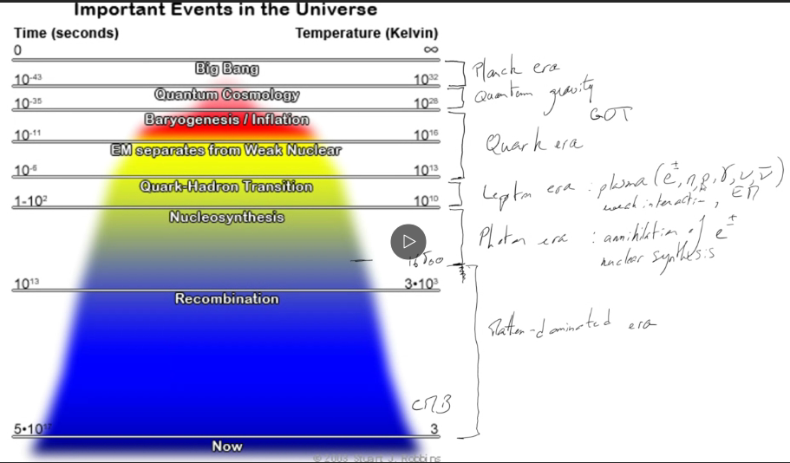

### **4.3.3 Physis of the Big Bang**

* Baryogenesis during the quark era: imbalance in the baryon-to-photon ratio
* Primordial nucleosynthesis before the radiation-dominated era:
  + Weak interaction processes (see Feynman diagrams including associated bosons)
  + Thermodynamic equilibrium with Saha’s law and binding energy
  + Freeze out time for a neutron-to-proton ration of 0.2
  + Fusion of proton, recombination of H and deuterium synthesis
  + Beyond Deuterium, starting to make heavier elements such as Li. Be is created through the triple alpha process

From lepton era $→$ photon era

Weak interaction,

Boson

$n+ν_{e}↔p+e^{-}$

$n+e^{+}↔p+{\overline{ν}}_{e}$

Feynman diagram of 2

p

n

νe

e+

W+

#### **4.3.3.1 Kinetic equilibrium (thermodynamics)**

Number density of neutrons: $n_{n}=g_{n}{\left(\frac{m_{n}k_{B}T}{2πℏ^{2}}\right)}^{\frac{3}{2}}\exp\left(-\frac{m_{n}c^{2}}{k_{B}T}\right)$

Number density of protons: $n_{p}=g_{p}{\left(\frac{m_{p}k_{B}T}{2πℏ^{2}}\right)}^{\frac{3}{2}}\exp\left(-\frac{m_{p}c^{2}}{k_{B}T}\right)$

$$g_{n}=g_{p}=2$$

$$\frac{n_{n}}{n_{p}}={\left(\frac{m_{n}}{m_{p}}\right)}^{\frac{3}{2}}\exp\left(\frac{\left(m_{n}-m_{p}\right)c^{2}}{k_{B}T}\right)$$

During the lepton era: $n_{n}=n_{p} \frac{n_{n}}{n_{p}}=1$

From lepton era: $T 1\frac{n_{n}}{n_{p}}≪1, n_{p}>n_{n}$

#### **4.3.3.2 Freeze at time:**

At T=9x109K, freeze at time, tfreeze 1s

$$\left(m_{n}-m_{p}\right)c^{2}≈1.3 MeV$$

Halftime of process: $k_{B}T≈0.8MeV$

$$n→e^{-}+p+{\overline{ν}}_{e}$$

$$\frac{n_{n}}{n_{p}}=\exp\left(-\frac{1.3meV}{0.8MeV}\right)≈0.2 at freeze at time$$

#### **4.3.3.3 Deuterium synthesis**

$n+p↔D+γ$ Very efficient reaction

$\operatorname{For}{T}>1.1x{10}^{9}K$ Not building D abundance

$For T<1.1x{10}^{9}K$ Efficient in producing D, t $\sim$ 2s

Binding energy: $B_{D}=\left(m_{n}+m_{p}-m_{D}\right)c^{2}=2.2 MeV$

$$\frac{n_{D}}{n_{n}n_{p}}=6{\left(\frac{m_{n}k_{B}T}{πℏ^{2}}\right)}^{-\frac{3}{2}}\exp\left(\frac{B_{D}}{k_{B}T}\right)$$

When $k_{B}T→0$ Deuterium is favoured

$T \frac{n_{D}}{n_{n}n_{p}}$ exponentially

#### **4.3.3.4 Other mechanisms**

Fusion of protons

2He (dipolar)

2He

Very inefficient, takes a long time

Beyond Deuterium synthesis

3He +

3H+ (3H: tritium)

3H spontaneously decays into 3He

Fusion of Deuterium

4

Or 3H

Or 3

Decay of 3H and 3He

34

34

34

34

Formation of light elements

* Lithium

4 6  6Li is unstable

43 7

* Beryllium

43 7 7Be is unstable

448

## **4.4 Miscellaneous topics**

### **4.4.1 The Horizon problem**

Horizon distance: dH =

For a radiation dominated universe:

$$d_{H}=2ct_{0}$$

For a matter dominated universe:

$$d_{H}=3ct_{0}$$

What is the horizon problem?

CMB thermal radiation coming from the Big Bang

Isotropic distribution at the present time

Big Bang

t=0

t/s

Last scattering

**t0**

rls

RH

Proper distance for last scattering: $d_{ls}=\frac{ct{}_{0}}{z_{ls}}$

Radius of horizon: $R_{H}=3ct_{ls}≈\frac{1}{10}d_{ls}$

Corresponding angle $θ$:

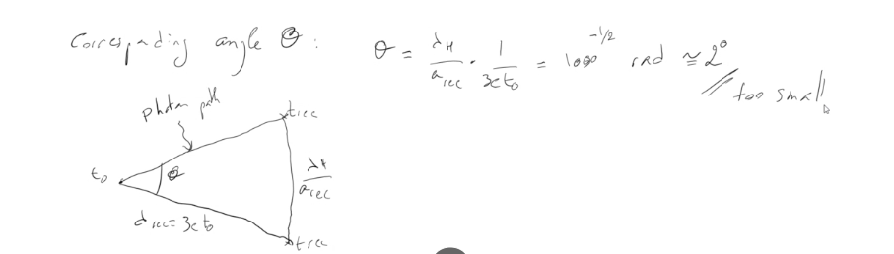

### **4.4.2 The flatness problem**

Friedmann equation: $H^{2}={\left(\frac{\dot{a}}{a}\right)}^{2}=\frac{8πG}{3}ρ-\frac{Kc^{2}}{a^{2}}$

$$Ω:density parameter$$

$$1=Ω-\frac{Kc^{2}}{H^{2}a^{2}}$$

$1-Ω= -\frac{Kc^{2}}{H^{2}a^{2}}$ At t=0

$1-Ω_{0}=-K{\left(\frac{\left(\frac{c}{H_{0}}\right)}{a_{0}}\right)}^{2}$ At present time

Observed value: $\left|1-Ω_{0}\right|≤0.005$ Near flat universe

Flatness at the big bang

Radiation + matter dominated universe: ${\left(\frac{H}{H_{0}}\right)}^{2}=\frac{Ω_{r,0}}{a^{4}}+\frac{Ω_{m,0}}{a^{3}}$

$$1-Ω=\frac{\left(1-Ω_{0}\right)a^{2}}{Ω_{r,0}+aΩ_{m,0}}$$

Use the benchmark: $Ω_{r,0 }=9x{10}^{-5}, Ω_{m,0}≈0.31, Ω_{n,0}≈0.69$

$$Ω_{r,0 }=radiation, Ω_{m,0}=matter, Ω_{n,0}:dark matter$$

$$\left|1-Ω\right|≤0.005$$

Radiation + matter: $\left|1-Ω_{r,m}\right|≤2x{10}^{-6}$

For nucleosynthesis: $\left(a_{nc}≈3.6x{10}^{-9}\right)$

$$\left|1-Ω_{nc}\right|≤7x{10}^{-16}$$

At Planck time: $\left|1-Ω_{p}\right|≤2x{10}^{-62}$

This is a problem with the current model

Solution: Inflation

Definition: The hypothesis that there was a period of time early in the history of the universe when the expansion was accelerating outward, $\ddot{a}>0$

Second Friedmann equation: $\frac{\ddot{a}}{a}=\frac{-4πG}{3}\left(ρ+\frac{3p}{c^{2}}\right)=-\frac{4πG}{3c^{2}}\left(ε+3p\right)$

Energy density: $ε=ρc^{2}$

For inflation: $\ddot{a}>0$ $ε+3p<0$ $$p<-\frac{ε}{3}$$

Simple model by assuming positive cosmological constant, $Λ_{i}$

$$\frac{\ddot{a}}{a}=\frac{Λ_{i}}{3}>0$$

And ${\left(\frac{\dot{a}}{a}\right)}^{2}=\frac{Λ_{i}}{3}$ (similar de Sitta model)

This, Hi is a constant, $H_{i}={\left(\frac{Λ_{i}}{3}\right)}^{\frac{1}{2}}$

$a\left(t\right) α e^{H_{i}t}$

Include inflation: inflation starting at time ti and then ending at time tf­ within the radiation-dominated era

$$a=\left(\begin{matrix}a_{i}{\left(\frac{t}{t_{i}}\right)}^{\frac{1}{2}} \\ a_{i}e^{H_{i}\left(t-t_{i}\right)} \\ a_{i}e^{H_{i}\left(t_{f}-t_{i}\right)}{\left(\frac{t}{t_{f}}\right)}^{\frac{1}{2}}\end{matrix}\right)\begin{matrix}t<t_{i} \\ t_{i}≤t<t_{f} \\ t≥t_{f}\end{matrix}$$

During the inflation, the expansion factor has increased by

$$\frac{a\left(t_{f}\right)}{a(t)}=e^{N}$$

Where N is the number of e-folding of the inflation (the amount of times it has increased by an exponential)

$$N=H_{i}\left(t_{f}-t_{i}\right)$$

Example: $t_{i}={10}^{-36}s$ (grand unification theory)

$H_{i}={10}^{36}s^{-1}$

$$The energy density at the present time:ε_{Λ_{0}}=0.036 TeV m^{-3}$$

The energy density at inflation time: $ε_{Λ_{0}}={10}^{105} TeV m^{-3}$

$${ε_{Λ}}_{0}≫{ε_{Λ}}_{0}$$

Solving the Horizon problem

$$d_{H}\left(t\right)= a\left(t\right)c\int_{0}^{t}{\frac{dt^{'}}{a\left(t^{'}\right)}}$$

$$Prior to the inflation:d_{H}\left(t_{i}\right)=2ct_{i}$$

End of the inflation: $d_{H}\left(t_{f}\right)=a_{i}e^{N}c\left[\int_{0}^{t_{i}}{\frac{dt}{a_{i}{\left(\frac{t}{t_{i}}\right)}^{\frac{1}{2}}}}+\int_{t_{i}}^{t_{f}}{\frac{dt}{a_{i}e^{H_{i}\left(t-t_{i}\right)}}}\right]$

$$dH\left(t_{f}\right)=e^{N}c\left(2t_{i}+\frac{1}{H_{i}}\right)$$

Exponential growth

$At t_{i}={10}^{-36}s, d_{H}\left(t_{i}\right)≈6x{10}^{-28}m$

$At t_{f} with N=65, d_{H}\left(t_{f}\right)≈15m$

*

*

*Last scattering $Last scattering, d_{H}\left(t_{f}\right)→d_{H}\left(ls\right)≅200 Mpc$

Compare to $d_{H}\left(ls\right)≅0.25Mpc without inflation$

$θ\sim 2^{o}$

Solving the flatness problem

For inflation: $\left|1-Ω\left(t\right)\right| α e^{-2H_{i}t}$

At tf: (not flat before inflation)

$\sim 1$

$$\left|1-Ω\left(t_{f}\right)\right|=e^{-2N}$$

$$\left|1-Ω_{0}\right|≤0.005$$

Back in time: $a\left(t_{f}\right)\sim 2x{10}^{-28}\sqrt{N+1}$

$$\left|1-Ω\left(t_{f}\right)\right|≤2x{10}^{-54}\left(N+1\right)$$

Typically, $N=60$ to explain the flatness of the universe at the present time

### **4.4.3 Gravitational lensing (including lens equation and lens potentials)**

#### 4.4.3.1 Geometry configuration

$$ξ_{2}$$

$α-θ$ $α$ $α$

**S $ξ$**

$$ξ_{1}$$

**Lens $β$ $θ$ Observer**

$$D_{L}$$

$$D_{LS}$$

**DS**

Source plane

Image plane

#### 4.4.3.2Angle $α$:

$α$: deviation angle from a mass M for a massless particle coming from infinity and going to infinity.

M: Mass of the lens

Derivation obtained from the orbit equation in general relativity with Schwarzschild metric,

$α=\frac{4GM }{c^{2}ξ}=\frac{2R_{s}}{ξ}$ Where Rs is the Schwarzschild radius

$ξ$ is the impact parameter

For the Sun: Light grazing on the surface

$$α=\frac{4GM_{⊙}}{c^{2}R_{⊙}}=1.7 arcsecond$$

For small angles: The visibility conditions are:

$θ≈\frac{ξ}{D_{L}}$ (tan $θ$)

$$β=\frac{ξ_{1}}{D_{S}}=ξ_{1}=βD_{S}$$

$$α-θ=\frac{ξ_{2}}{D_{LS}}→ξ_{2}=\left(α-θ\right)D_{LS}$$

$$ξ≈βD_{S}+\left(α-θ\right)D_{LS}$$

$$βD_{S}=ξ-\left(α-θ\right)D_{LS}$$

$$βD_{S}=ξ-\left(α-\frac{ξ}{D_{L}}\right)D_{LS}$$

$$βD_{S}=\left(1+\frac{D_{LS}}{D_{L}}\right)ξ-αD_{LS}$$

$βD_{S}=\left(\frac{D_{L}+D_{LS}}{D_{L}}\right)ξ-\frac{2R_{s}}{ξ}D_{LS}$ With $D_{L}+D_{LS}=D_{S}$

$$\left(divide by D_{S}\right) β=\frac{ξ}{D_{L}}-\frac{2R_{s}}{ξ}\frac{D_{LS}}{D_{S}}→β=θ-\frac{D_{LS}}{D_{S}} α$$

This is the lens equation

$β$: Source plane

$θ$: Image plane

$\frac{D_{LS}}{D_{S}}α$: deviation by massive object

If $β=0$: Source and lens are aligned with observer

$$θ=\frac{D_{Ls}}{D_{S}}α$$

$$\frac{ξ_{0}}{D_{L}}=\frac{D_{LS}}{D_{S}}*\frac{2R_{s}}{ξ_{0}}$$

$$ξ_{0}^{2}=\frac{D_{LS}D_{L}}{D_{S}}2R_{s}=\frac{D_{LS}D_{L}}{D_{S}}*\frac{4GM}{c^{2}}$$

This corresponds to the Einstein ring of radius $ξ_{0}$

#### 4.4.3.3 General lens equation

$$\underline{β}=\underline{θ}-∇φ\left(\underline{θ}\right)$$

$$\underline{β}:In the source plane$$

$$\underline{θ}=in the image plane$$

$$∇φ\left(\underline{θ}\right):lens potential$$

Lens potential: $φ\left(\underline{θ}\right)=\frac{2}{c^{2}}\frac{D_{LS}}{D_{S}D_{L}} ϕ\left(\underline{θ}\right) Gravitational potential$

Transformation from image plane $\left(\underline{θ}\right)$ to source plane $\left(\underline{β}\right)$

Jacobian matrix: $J=\left(\frac{∂\underline{θ}}{∂\underline{β}}\right)$

Definitions:

* a: amplification matrix $a^{-1}=J$
* A: amplification $A^{-1}=\det\left(a^{-1}\right)$

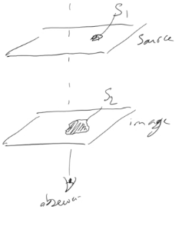

$$A=\frac{S_{1}}{S_{2}}{\left(\frac{D_{S}}{D_{L}}\right)}^{2}$$

Critical lines:

Points in the image plane, such as the amplification is infinite

$$\frac{p\left(x,y\right)}{A^{-1}\left(p\right)}=\det\left(a^{-1}\left(a,y\right)\right)=0$$

Caustic lines:

The caustic lines are obtained from the transformation of the critical lines

$\underline{β}=T\left(\underline{θ}\right)$ $T\left(\underline{θ}\right)= \underline{θ}-∇φ\left(\underline{θ}\right)$

Gradient in polar coordinates $(r, θ)$: $\left(∂_{r},\frac{1}{r}∂_{θ}\right)$ with $∂_{r}=\frac{∂}{∂r} and ∂_{θ}=\frac{∂}{∂θ}$

$$T_{r}\left(r,θ\right)=r-∂_{r}φ$$

$$T_{θ}\left(r,θ\right)=-\frac{1}{r}∂_{θ}φ$$

$$a^{-1}=\left(\begin{matrix}1-∂_{rr}φ & -∂_{r}\left(\frac{1}{r}∂_{θ}φ\right) \\ -∂_{r}\left(\frac{1}{r}∂_{θ}φ\right) & -1-\frac{1}{r}∂_{r}φ-\frac{1}{r^{2}}∂_{θθ}φ\end{matrix}\right)$$

With $∂_{rr}=\frac{∂^{2}r}{∂r^{2}}$ and $∂_{θθ}=\frac{∂^{2}θ}{∂θ^{2} }$

For circular symmetry $\left(∂_{θ}=0\right)$

$$a^{-1}=\left(\begin{matrix}1-∂_{rr}φ & 0 \\ 0 & -1-\frac{1}{r}∂_{r}φ\end{matrix}\right)$$

$$\det\left(a^{-1}\right)=\left(1-∂_{rr}φ\right)\left(-1-\frac{1}{r}∂_{rr}φ\right)$$

$$Critical lines:\det\left(a^{-1}\right)=0=\left(1-∂_{rr}φ\right)\left(-1-\frac{1}{r}∂_{r}φ\right)$$

$$→Critical lines are circles$$

Observations:

Image plane

Radial critical lines

Tangential critical lines

Order of magnitude:

Case of galaxy lens: $α≈\frac{4πσ^{2} }{c^{2}}$

$$with σ=velocity dispersion$$

$$α≈2^{''}{\left[\frac{σ}{300km s^{-1}}\right]}^{2}$$

For a single galaxy $σ_{g}\sim 300 km s^{-1}→α≈2^{''}$

For a galaxy cluster $σ_{c}\sim {10}^{3}km s^{-1}→α≈{20}^{''}$ (easier to observe)

Examples

1. Point-mass lens

* Gravitational potential: $ϕ=\frac{GM}{3}$

$α\left(ξ\right)=\frac{4GM}{c^{2}}\frac{ξ}{\left|ξ^{2}\right|}$

$Einsten angle:θ_{E}={\left(\frac{4GM}{c^{2}}\frac{D_{LS}}{D_{S}D_{S}}\right)}^{\frac{1}{2}}$

$lens equation:β=θ-θ_{E}^{2}\frac{θ}{{\left|θ\right|}^{2}}$

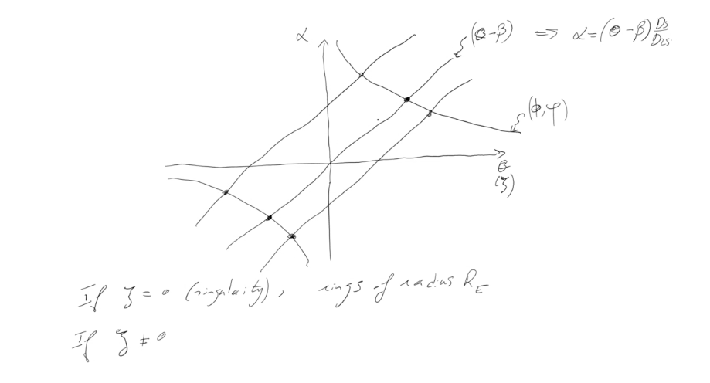

1. Isothermal sphere

* Density distribution: $ρ \left(r\right)=\frac{σ_{0}^{2}}{2πGr^{2} }→$ There is a singularity at r=0
* Lens potential: $φ\left(r\right)=\frac{4πr_{0}^{2}}{c^{2}}\frac{D_{LS}}{D_{S}D_{L}} r$

$Einstein angle: θ_{E}=4π{\left(\frac{σ_{0}}{c}\right)}^{2}\frac{D_{LS}}{D_{S}}$

$$→β=θ-θ_{E}\frac{θ}{\left|θ\right|}$$

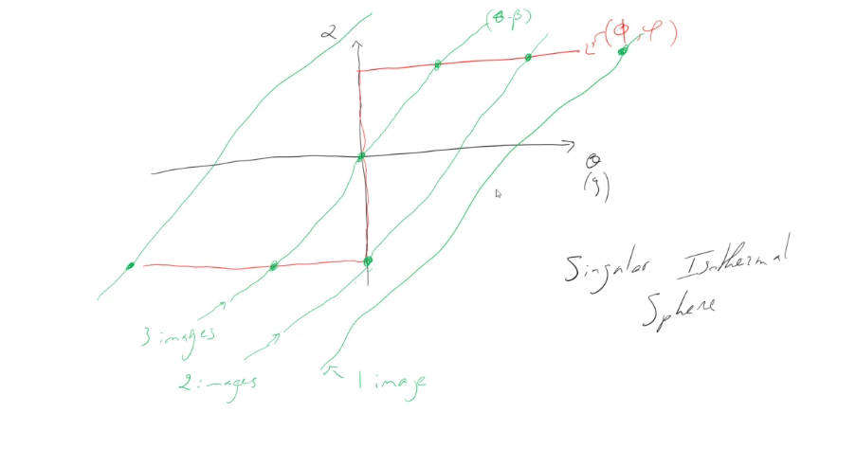

1. Isothermal sphere (without singularity)

$φ\left(r\right)=\frac{6πr_{0}^{2}}{c^{2}}\frac{D_{LS}}{D_{S}} r_{c}\sqrt{1+{\left(\frac{r}{r_{c}}\right)}^{2}}$

* Lens equation: $β=ξ-\frac{φ_{0}}{r_{C}}\frac{ξ}{\sqrt{ξ^{2}+r_{c}^{2}}}$

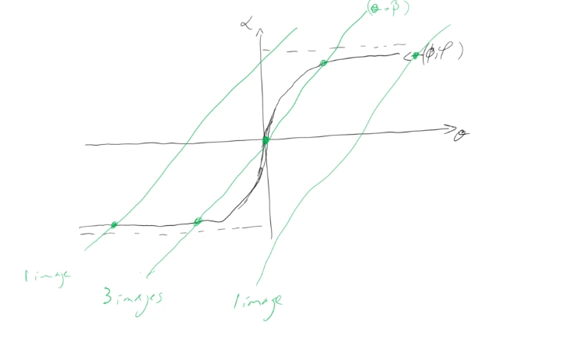

### **4.4 Gravitational waves (including wave equation in general relativity)**

1. Classical description: Internal gravity waves

Hydrostatic equilibrium: $\frac{dp_{0}}{dz}=-ρ_{0}g$

Perturbation: $p+δp, ρ_{0}+δρ, z+δz$

Definition: $δρ=\frac{∂ρ}{∂z} δz$

$δρ=c_{s}^{2}δρ$

Frequency, $ν$ is $Brunt-V\dot{a}is\ddot{a}l\ddot{a} frequency$

$ν^{2}=\frac{g^{2}}{c_{s}^{2}}\left(γ-\frac{c_{s}^{2}}{c_{s}^{2}+V_{A}^{2}}\right)$ MHD approximation

1. General relativity

$g_{μν}=η_{μν}+h_{μν}$ With $\left|h_{μν}\right|≪1$

General potential: ${\overline{h}}_{μν}=h_{μν}-\frac{1}{2}η_{μν}h$ With $h=h_{α}^{α}=η^{αβ}h_{αβ}$

Linearised Einstein’s field equation

$$-{\overline{h}}_{μν,α}^{α}-η_{μν} {\overline{h}}_{αβ,β}^{α}+{\overline{h}}_{μα,ν}^{α}+{\overline{h}}_{να,μ}^{α}=16πT_{μν}$$

$T_{μν}$ is the energy-transformation tensor

For a flat universe, weak field approximation:

$$ds^{2}=\left(1-\frac{2Π}{r}\right)dt^{2}-\left(1+\frac{2Π}{r}\right)\left(dr^{2}+r^{2}dθ^{2}+r^{2}{\sin^{2}{θ} dρ^{2}}\right)$$

Simplest solution: ${\overline{h}}_{μν, α}^{α}=0→$ monochromatic plane wave

$→ {\overline{h}}_{μν}=A_{μν}e^{ik_{α}x^{α}}$

Gravitational wave “Luminosity”

$$L_{GW}\sim {\left(\frac{Π}{R}\right)}^{r}L_{0}$$

$$L_{0}≈3.63 {10}^{59} erg s^{-1}$$

Gravitational wave observations

* Stellar collapse, black hole formation
* Objects falling into a black hole
* Collision of black holes
* Supernovae explosion
* Young pulsars
* Primordial universe

Observed recently: gravitational waves coming from binary systems (black holes, neutron stars)

### **4.5 Black holes (including Schwarzschild metric, Hawking radiation, event horizon)**

Singularity

At the very centre of the black hole, matter has collapsed into a region of infinite density. All the matter and energy that falls into the black hole ends up here. The prediction of infinite density by general relativity is though to indicate the breakdown of the theory where quantum effects become important.

Event Horizon

This is the radius around a singularity where matter and energy cannot escape the black hole’s gravity: the point of no return. This is the “black” part of the black hole.

Photon sphere

Although the black hole itself is dark, photons are emitted from nearby hot plasma in jets or an accretion disk (see below). In the absence of gravity, these photons would travel in straight lines, but just outside the event horizon of a black hole, gravity is strong enough to bend their paths, so we see a bright ring surrounding a roughly circular “dark shadow”.

Relativistic jets

When a black hole feeds on stars, gas or dust, the meal produces jets of particles and radiation blasting out from the black hole’s poles at near light speed. They can extend for 1000’s of light years into space.

Innermost stable orbit

The inner edge of an accretion disk is the last place that material can orbit safely without the risk of passing the point of no return.

Accretion disk

A disc of superheated gas and dust whirls around a black hole at immense speeds, producing electromagnetic radiation (x-rays, optical, infrared and radio) that reveal the black hole’s location. Some of this material is doomed to cross the event horizon, while other parts may be forced out to create jets.

Classification

|  |  |  |
| --- | --- | --- |
| Class | Mass | Size |
| Supermassive | ~105-109 Mʘ | ~ 0.001-10 AU |
| Intermediate-mass | ~ 103 Mʘ | ~ 103km = REarth |
| Stellar | ~ 10 Mʘ | ~ 30km |
| Micro | Up to ~MMoon | Up to ~ 0.1mm |

Schwarzschild metric

$$ds^{2}=c^{2}dτ^{2}=c^{2}\left(1-\frac{r_{s}}{r}\right)dt^{2}-\frac{dr^{2}}{1-\frac{r_{s}}{r}}-r^{2}dθ^{2}-r^{2}\sin^{2}{θ}dφ^{2}$$

With $r_{s}=\frac{2GM}{c^{2}} is the Schwarzschild radius=event horizon$

10Mʘ:

106 Mʘ:

Mʘ:

Photon inside the black hole

$$1-\frac{r_{s}}{r}<0$$

$dθ=dφ=0$ $ds^{2}=c^{2}\left(1-\frac{r_{s}}{r}\right)dt^{2}-\frac{dr^{2}}{1-\frac{r_{s}}{r}}=0$

$$dr^{2}=c^{2}{\left(1-\frac{r_{s}}{r}\right)}^{2}dt^{2}$$

Photon moving towards the event horizon: $r→r_{s}$

$$\lim_{r→r_{s}}{1-\frac{r_{s}}{r}}=0$$

$$dr has to be finite$$

$∴dt→∞$ Photon cannot leave the black hole

Particle (starting at infinity) falling towards black hole

$$dθ=dφ=0$$

Energy conservation: $\frac{1}{2}m{\left(\frac{dr}{dτ}\right)}^{2}-\frac{GMm}{r}=0$

Kinetic Potential

$${\left(\frac{dr}{dτ}\right)}^{2}=\frac{2GM}{r}$$

$$dr=-\sqrt{\frac{2GM}{r}}dt$$

$$\frac{1}{\sqrt{2GM}}\sqrt{r} dr= -dt$$

$$\frac{1}{\sqrt{2GM}} \int_{r}^{0}{{r^{'}}^{\frac{1}{2}}}dr^{'}= -\int_{τ}^{τ_{0}}{dτ^{'}}$$

$$τ_{0}-τ= -\frac{1}{\sqrt{2GM}}{\left[\frac{2}{3}{r^{'}}^{\frac{3}{2}}\right]}_{r}^{0}$$

$$τ=τ_{0}-\frac{2}{3c}*\frac{r^{\frac{3}{2}}}{r_{s}^{\frac{1}{2}}} No singularity$$

At event horizon

$$τ_{0}-τ=\frac{2r_{s}}{3c}$$

10Mʘ:

106Mʘ:

Hawking’s radiation

Temperature of a black hole: $ΔxΔp=ℏ$ $Δx=r_{s}$

$Δp=\frac{ℏ}{r_{s}}$

$$Δp=mΔv →mc^{2}=k_{B}T$$

$$mcΔv=k_{B}T→Δv=\frac{k_{B}T}{mc}$$

$$∴Δp=\frac{k_{B}T}{c}$$

$$T=\frac{ℏc}{r_{s}k_{B}}=\frac{ℏc^{3}}{2GMk_{B}}$$

Black body radiation

$$T=\frac{ℏc^{3}}{8πGMk_{B}}$$

$$T=\frac{ℏc^{3}}{2GMk_{B}}→\begin{matrix}10M_{ʘ}: T=6x{10}^{-9}K \\ {10}^{6}{ M}_{ʘ}: T=6x{10}^{-14}K\end{matrix}$$

Radiation: $E=σT^{4}$

$\frac{dE}{dτ}=4πr_{s}^{2}σT^{4}$

Kinetic: $\frac{dE}{dτ}= -\frac{d}{dτ}\left(Mc^{2}\right)=-c^{2}\frac{dM}{dτ}$

$$→\frac{dM}{dτ}= -\frac{4πr_{s}^{2}σT^{4} }{c^{2}}$$

Assumption: $T=constant$

$r_{s}=\frac{2GM}{c^{2}}$

$$\frac{dM}{dτ}=-\frac{4π}{c^{2}}{\left(\frac{2GM}{c^{2}}\right)}^{2}σT^{4}$$

$$\frac{dM}{dτ}=-\frac{16πG^{2}M^{2}}{c^{6}}σT^{4}$$

$$\frac{dM}{M^{2}}= -\frac{16πG^{2}}{c^{6}}σT^{4} dτ$$

$$\int_{0}^{M}{\frac{dM}{M^{2}}= -\frac{16πG^{2}}{c^{6}}σT^{4}\int_{0}^{τ}{dτ}}$$

$$\frac{1}{M}=\frac{16πG^{2}}{c^{6}}σT^{4} τ$$

$$τ=\frac{c^{6}}{16πG^{2}σT^{4}M}$$

10 Mʘ:

106 Mʘ:

If T is not constant

With

10Mʘ:

106 Mʘ:

**Summary – Multi-universes, $Λ-CDM$**

Multi-component universe

$$\frac{H^{2}}{H_{0}^{2}}=\frac{Ω_{r,0}}{a^{4}}+\frac{Ω_{m,0}}{a^{3} }+Ω_{Λ,0}+\frac{1-Ω_{0}}{a^{2}}$$

Radiation, Matter, Cosmological constant, curvature

$Ω$: Density parameter

$$Ω_{0}=Ω_{r,0}+Ω_{m,0}+Ω_{Λ,0}$$

Integrate to get a(t)

$$\int_{0}^{a}{\frac{da}{{\left[\frac{Ω_{r,0}}{a^{4}}+\frac{Ω_{m,0}}{a}+Ω_{a,0}a^{2}+\left(1-Ω_{0}\right)\right]}^{\frac{1}{2}}}}=H_{0}t$$

Standard model ($Λ-CDM, cold dark matter)$

Benchmark model

Radiation: Photons: $Ω_{γ,0}=5.35 {10}^{-5}$

Neutrinos: $Ω_{ν,0}= 3.65 {10}^{-5}$

Total radiation: $Ω_{r,0}=9.0 {10}^{-5}$

Matter: Baryonic matter: $Ω_{bary,0}=0.048$

Non-baryonic matter: $Ω_{dm,0}=0.262$

Total matter: $Ω_{m,0}=0.31$

Cosmological constant: $Ω_{Λ,0}≈0.69$

Important eras

Radiation-matter equality: $a_{rm}=2.9 {10}^{-4}$ $t_{rm}=0.05 Myr$

Matter- $Λ$ equality: $a_{mΛ}=0.77$ $t_{mΛ}=10.2 Gyr$

Present time: $a_{0}=1$ $t_{0}=13.7 Gyr$